Jenkins-04 Task-02-06

2. Setup a Jenkins CICD pipeline using Declarative pipeline using feature-1.1 branch. https://github.com/betawins/sabear_simplecutomerapp/tree/feature-1.1
stages:
Stage 1: Git Clone
Stage 2: SonarQube Integration
Stage 3: Maven Compilation
Stage 4: Nexus Artifactory
Stage 5: Slack Notification
Stage 6: Deploy On tomcat

Stage 1
Step by step Implementation:
Step 1: Verify is Jenkins is running on port number.
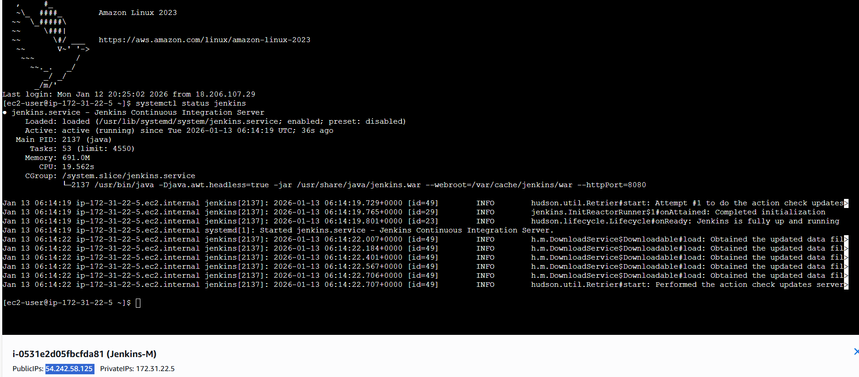

Step 2: Using the URL and port number- verify if Jenkins GUI is accessible.
- Verified.
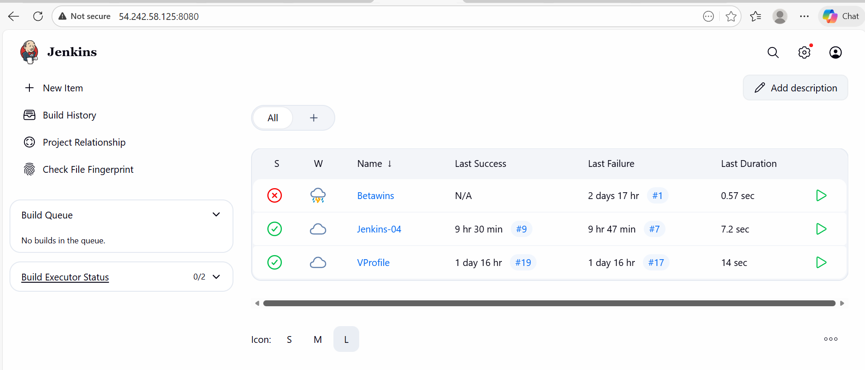

Step 3: Manage Jenkins Jenkins location to be updated if instance has been stopped.
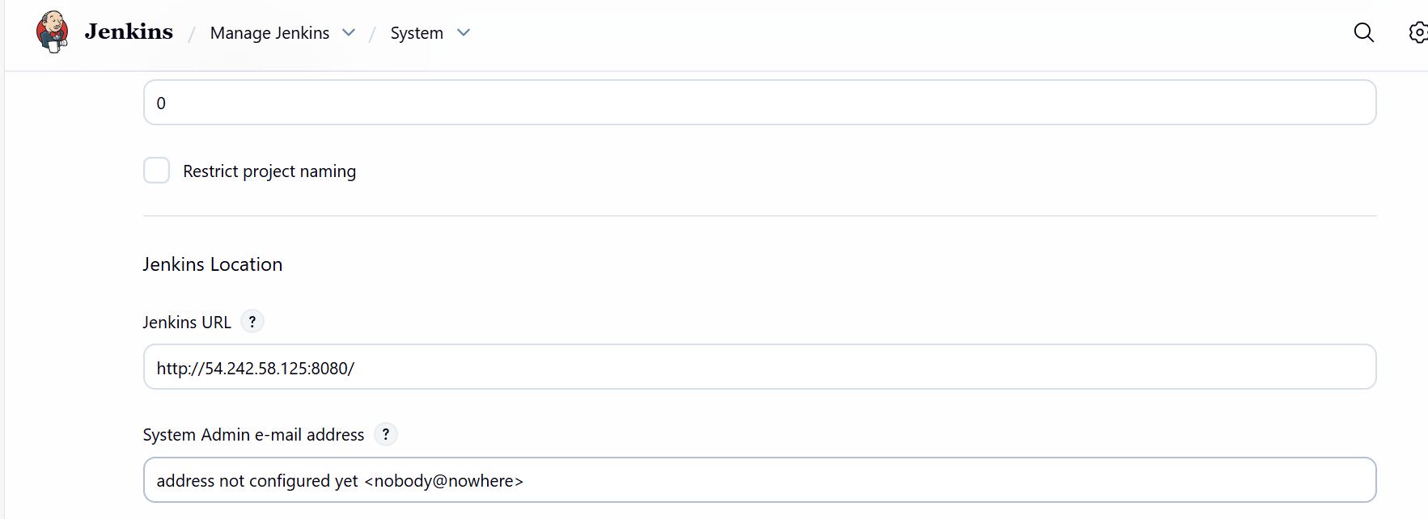

- Manage Jenkins Sonarqube servers Update the sonarqube URL if the instance has been stopped.
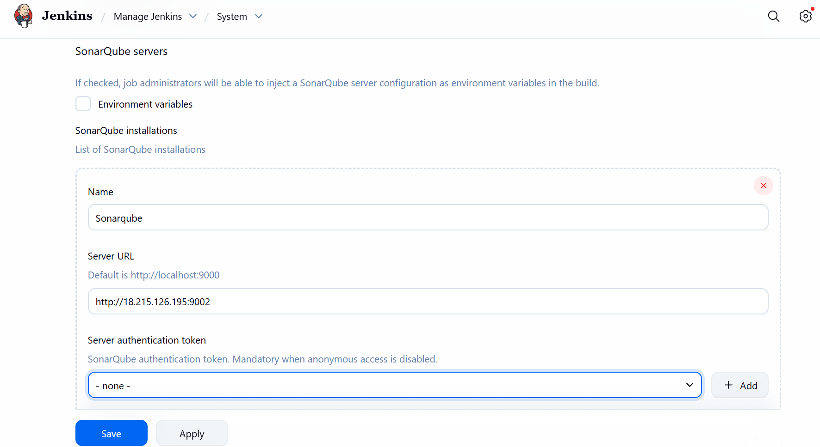

- Create a new credential if the instance has stopped, since Sonarqube will not have one if instance is stopped.
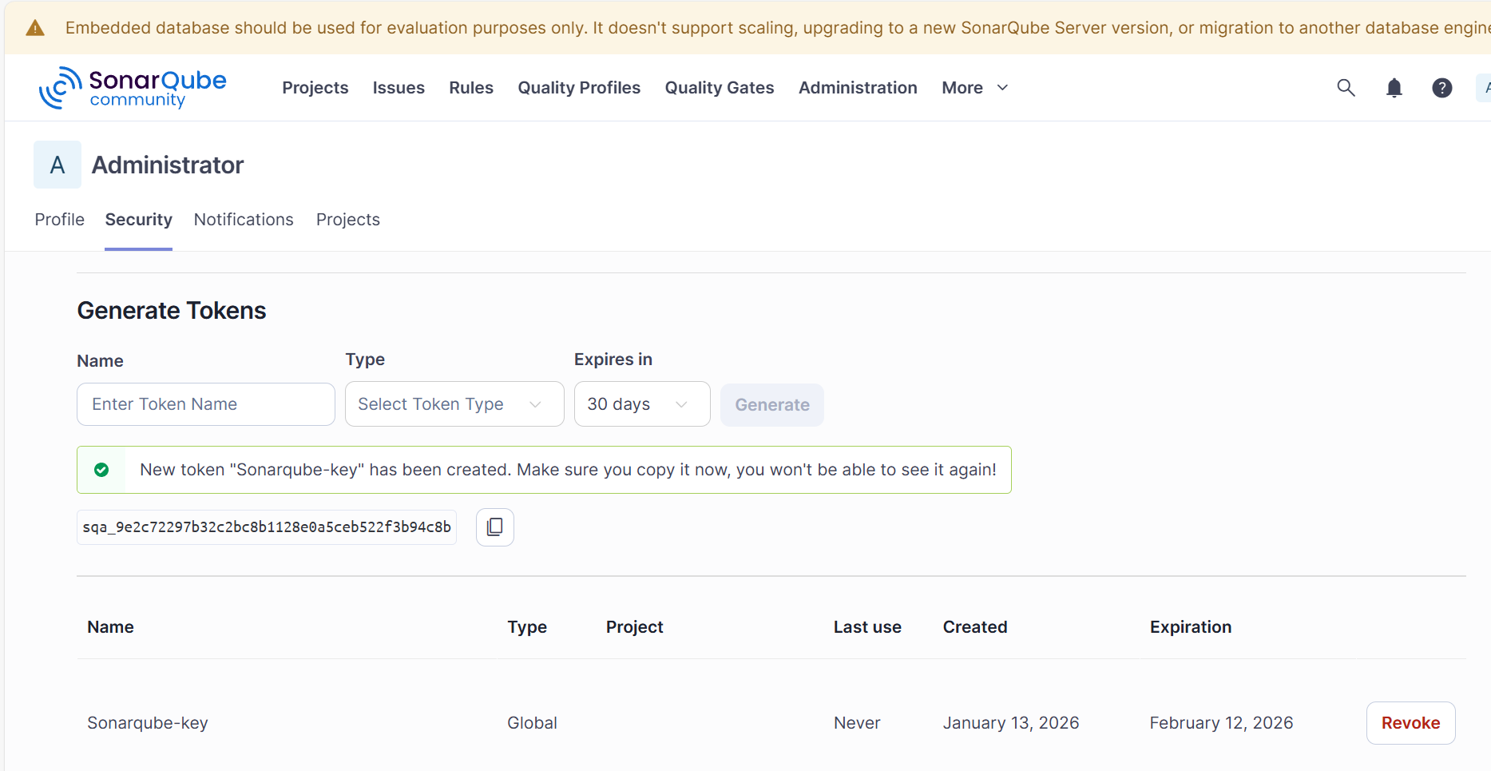
sqa_9e2c72297b32c2bc8b1128e0a5ceb522f3b94c8b
- New credential created with name- sonarqube-key
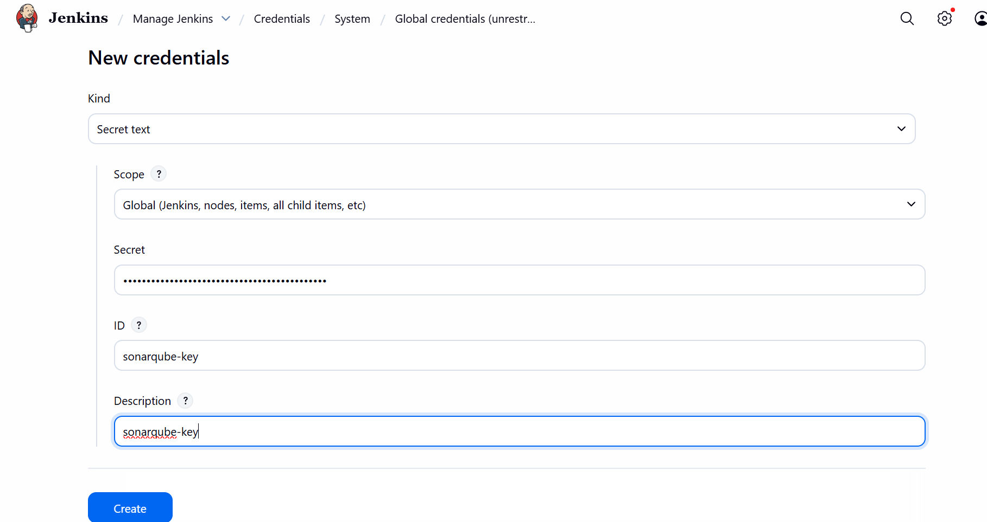

- Update the credential in Sonarqube server Manage Jenkins system
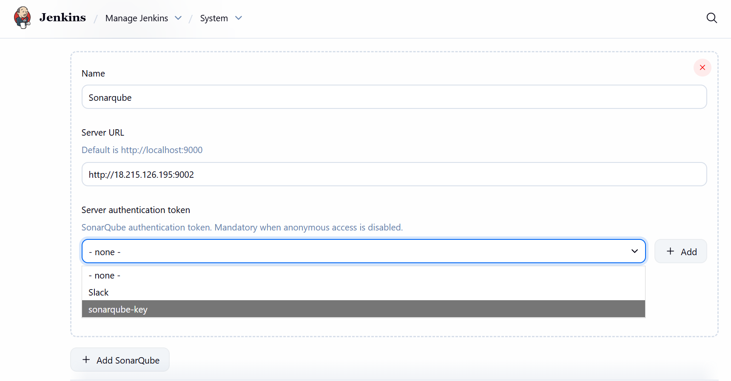

Step 4: We need to update the Sonarqube URL in Jenkins server, since we stopped the instance.
- Cd /opt/sonar-scanner/conf/
- Vi sonar-scanner. Properties
- Update the Sonarqube server URL and save.
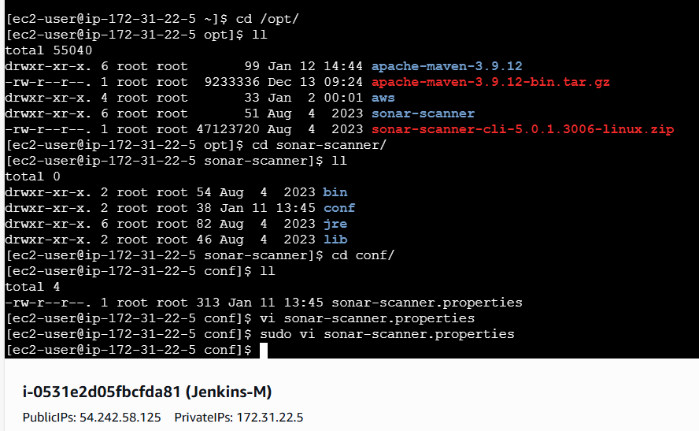
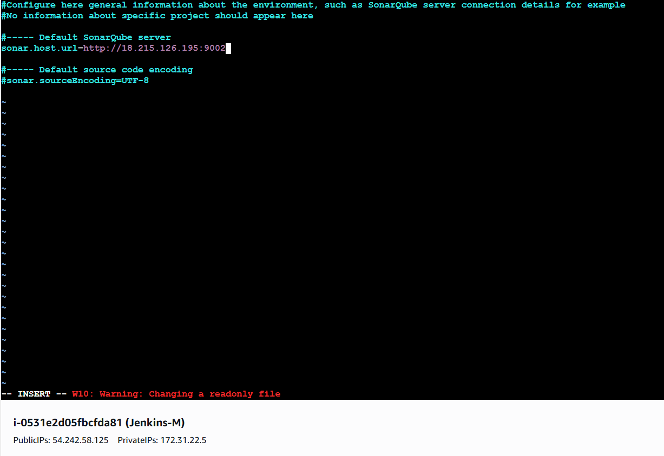

Stage 2
Start the Sonarqube instance and run below command to run the Sonarqube.
Step 5:
- Sudo docker run -itd -p 9002:9000 sonarqube
- Docker ps
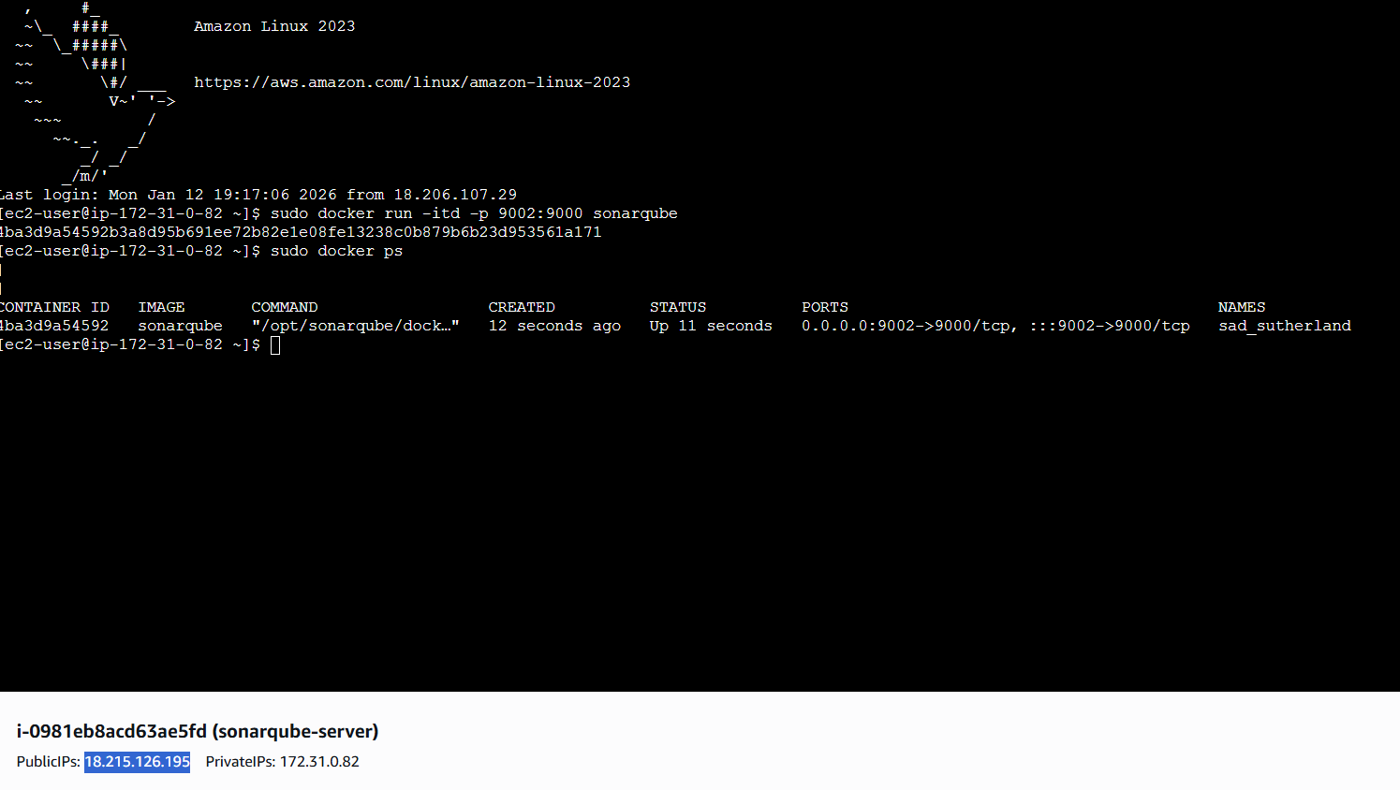
Step 6: Verify if the Sonarqube GUI is accessible with URL and port number.
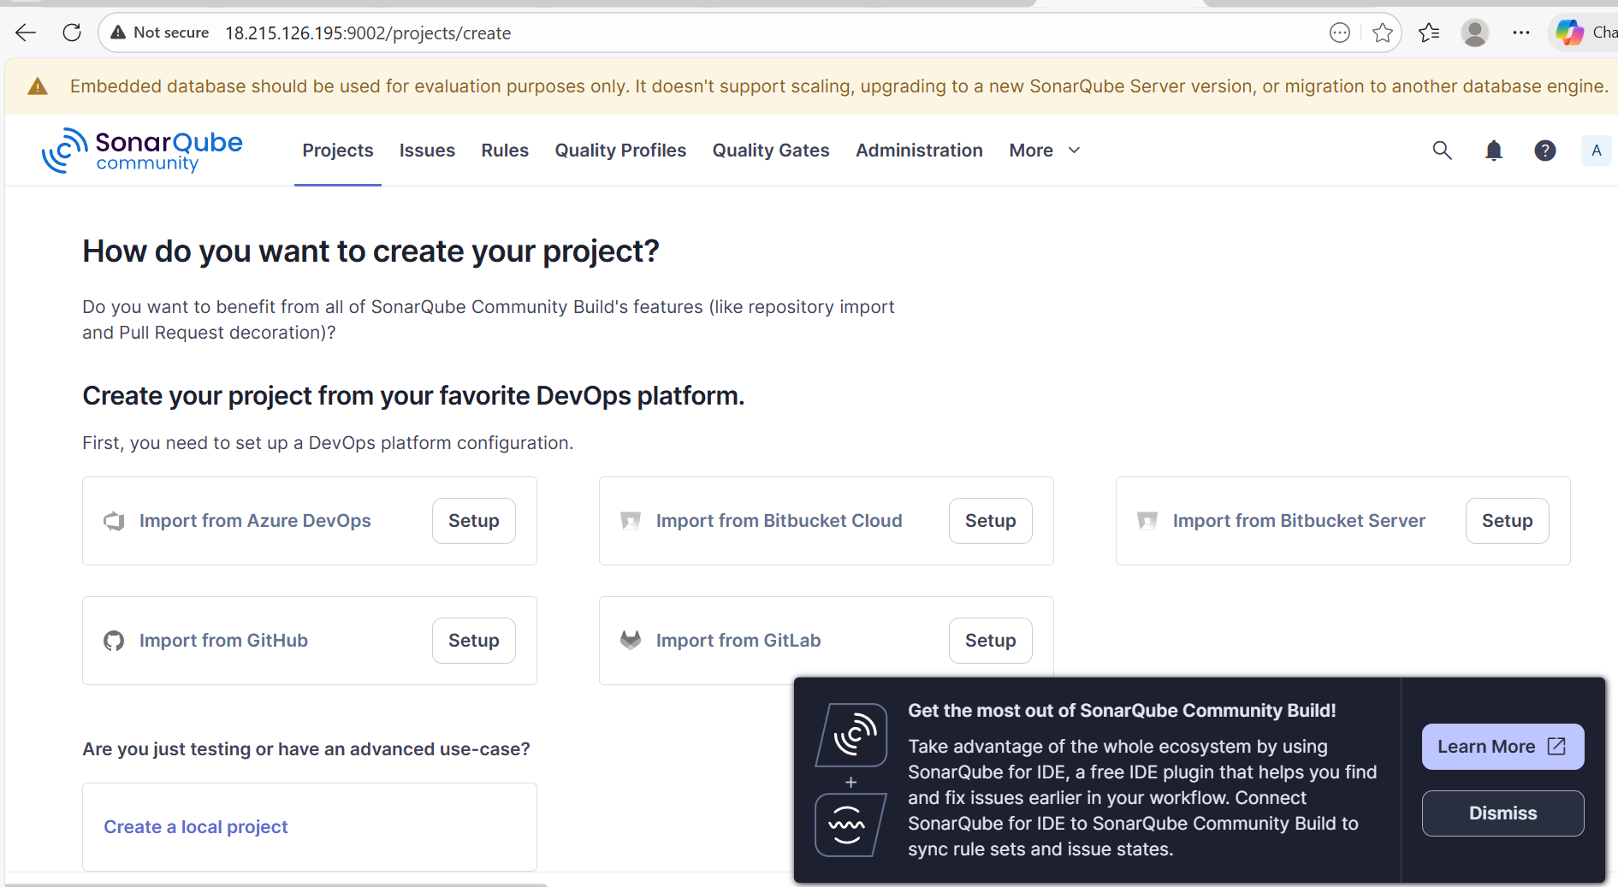

Step 7: Verify if the Sonar-scanner path is matching with Jenkins server.

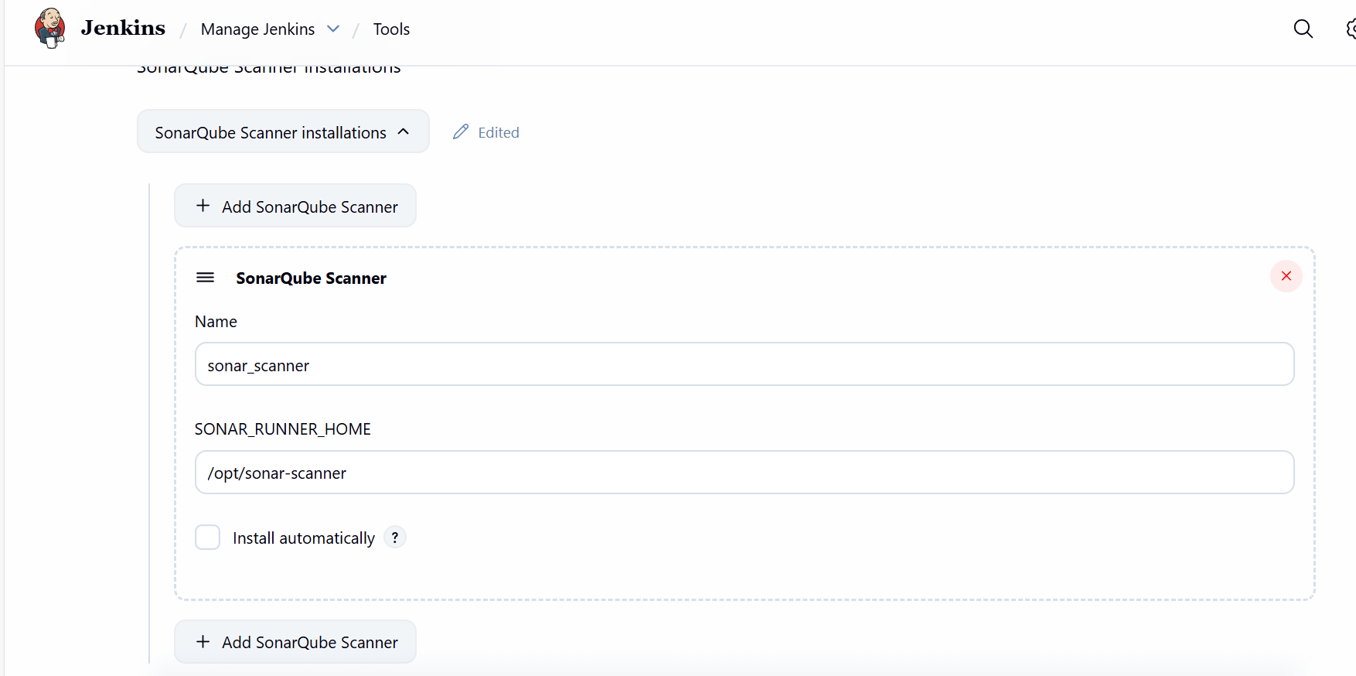
- Yes, the path is matching and verified.
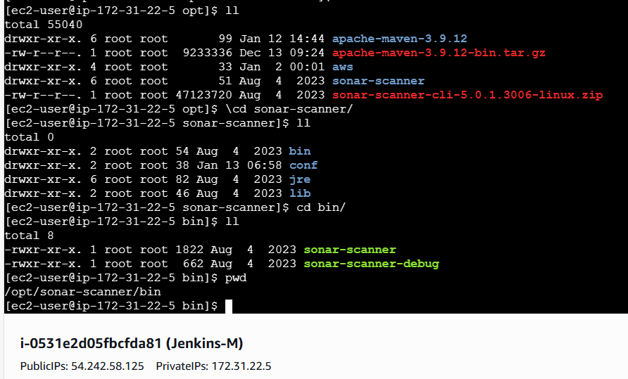

Stage 3
Maven Compilation
Step 8:
We launched Maven in Jenkins server, so we connected to Jenkins server and verified if Maven version globally available from cd /bin directory.
Mvn –version
MVN is up and running.
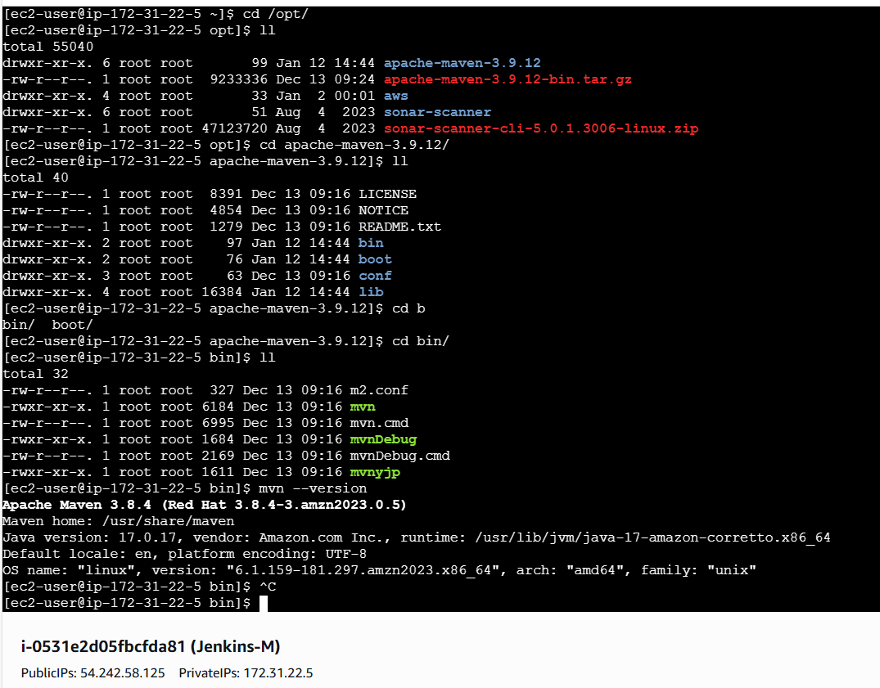

Step 9: Verify in the Jenkins GUI Tools Maven installations
Verify in the Jenkins server, if the path is present.
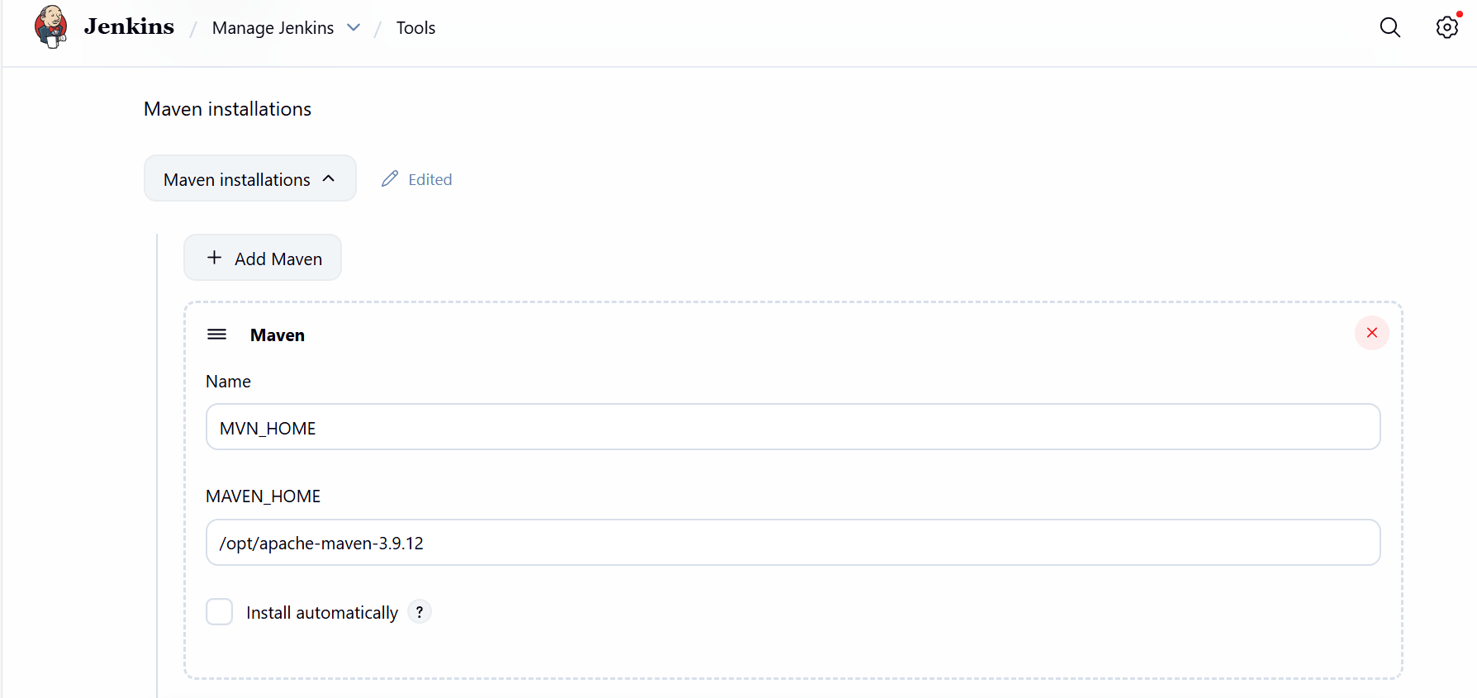

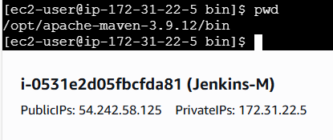

Stage 4
Nexus Repository
Step 10: Connect to Nexus server and verify if Nexus is working as expected.
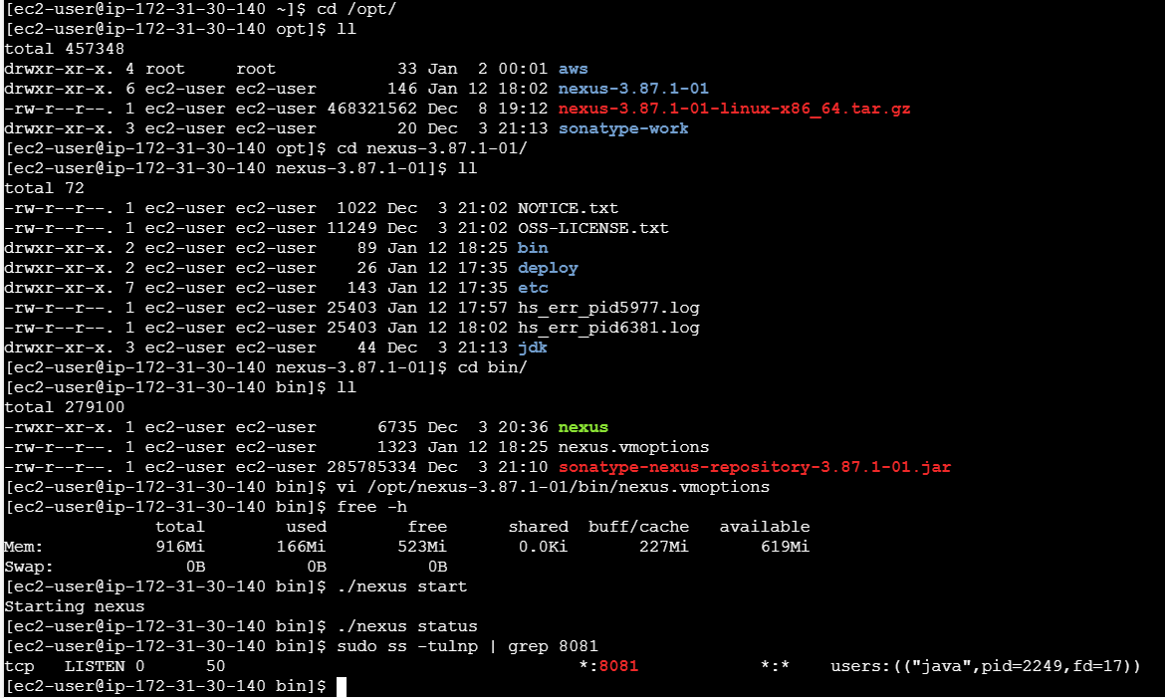

Step 11: Let’s verify if the browser is opening Nexus GUI.
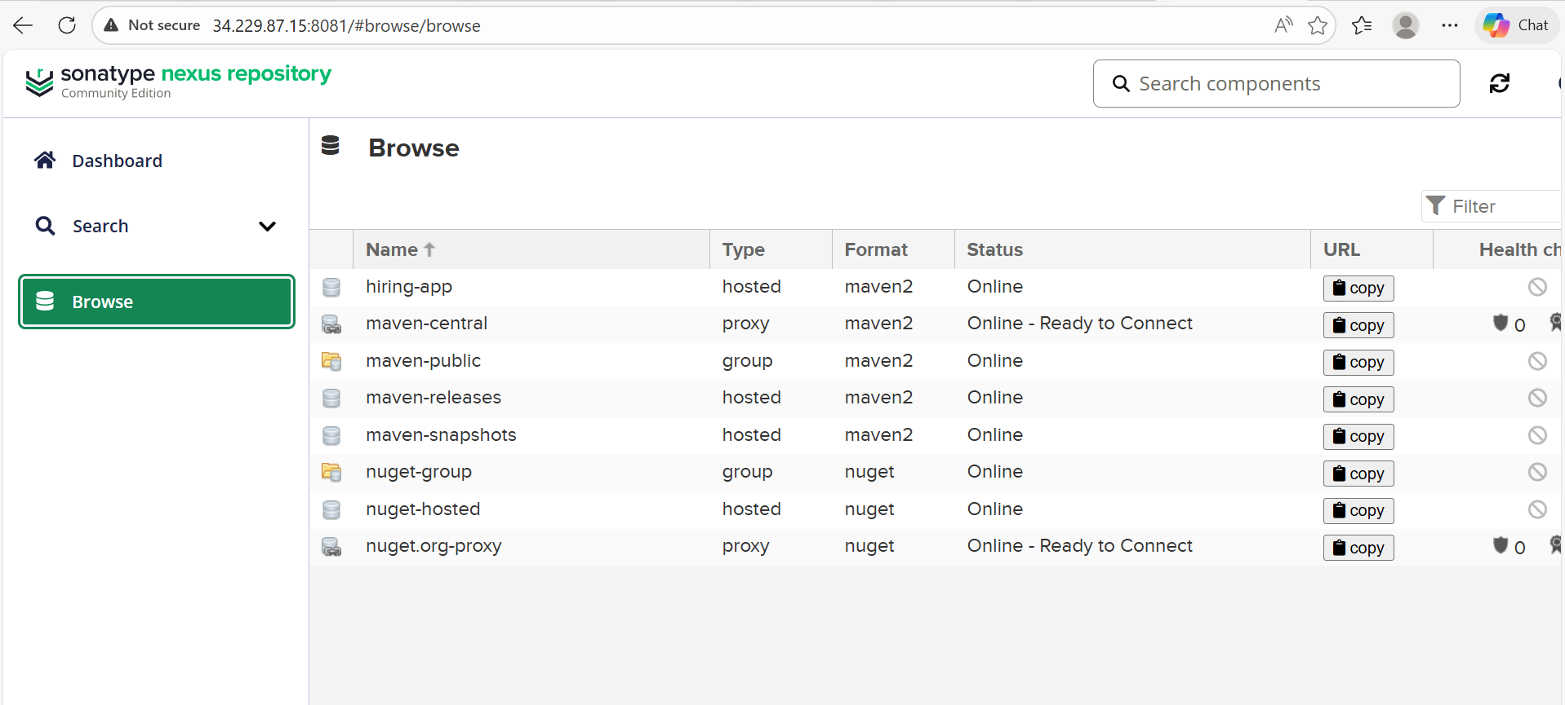

Step 12: Navigated to Jenkins URL and verified id Nexus credential is present.
Yes, credential is created earlier.
Username- nexus, Password – nexus123
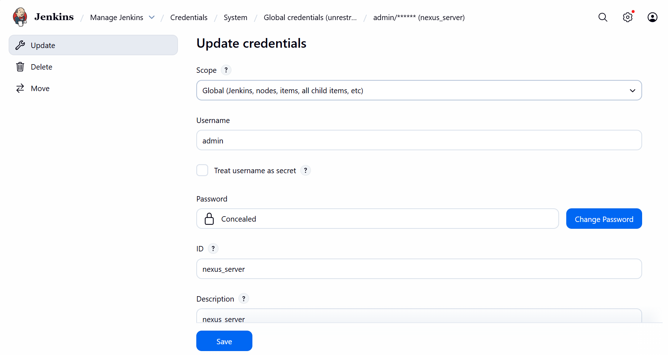

Stage 6
Tomcat Deployment
Step 13: Tomcat is up and running.

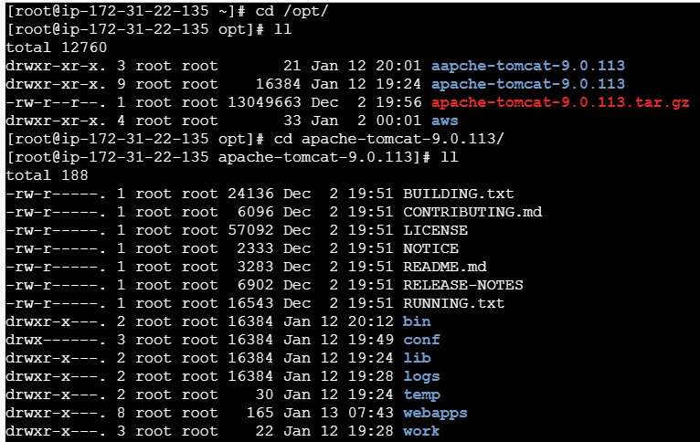

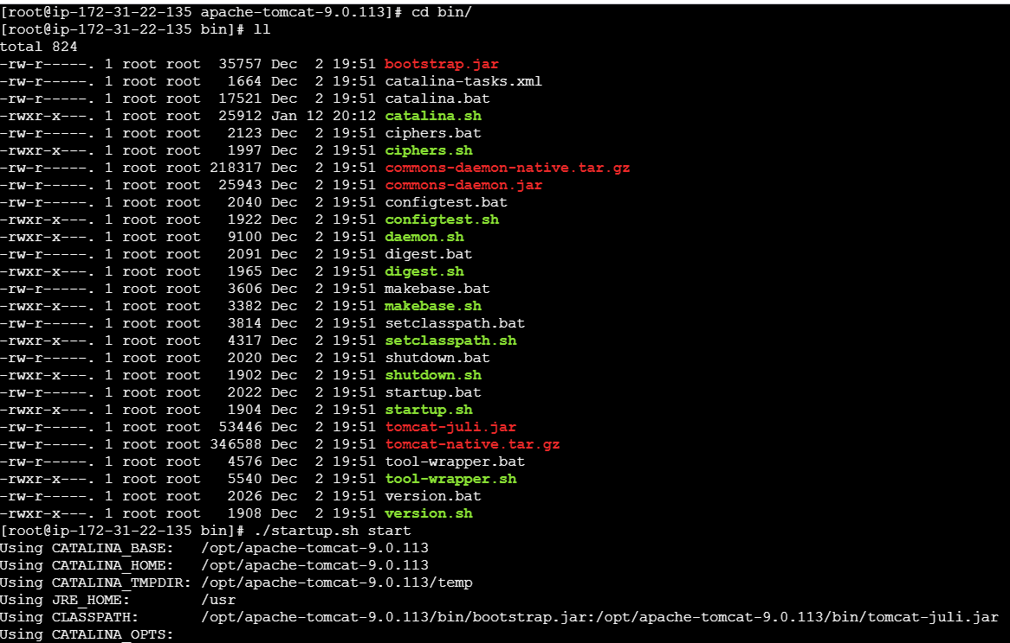
- Verified in browser, its working as expected.
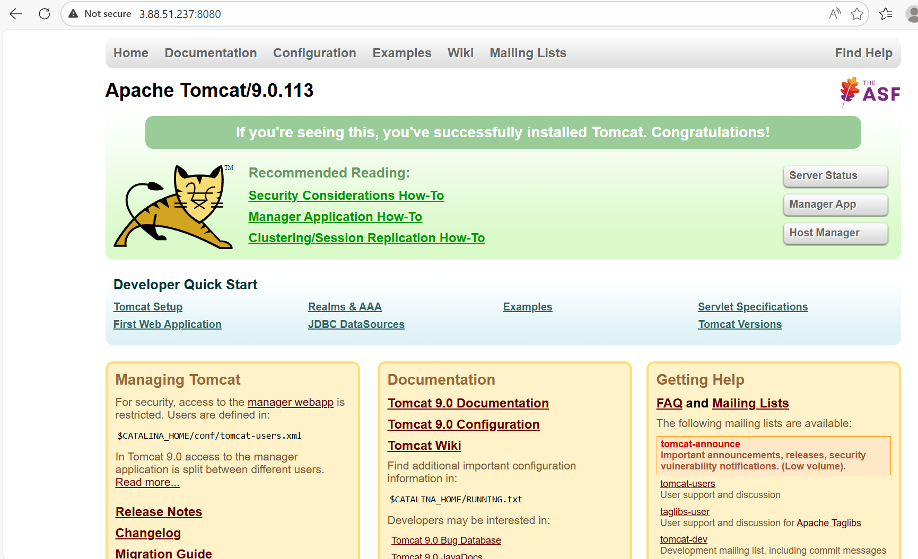

Step 14: Let’s navigate to Jenkins GUI and verify if the tomcat credentials are present, which we created earlier.

tomcat.users.xml Cd /opt/
Cd apache-tomcat-9.0.113/conf/tomcat-users.xml
Vi tomcat-users.xml
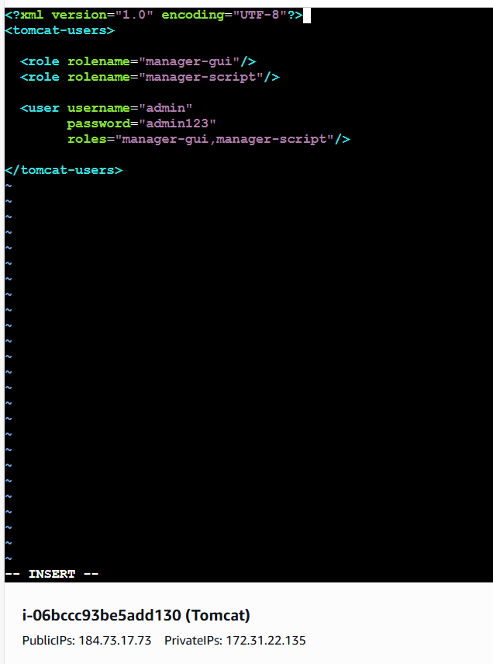

- Verified in Jenkins GUI, its present.
- Username- admin, password- admin123
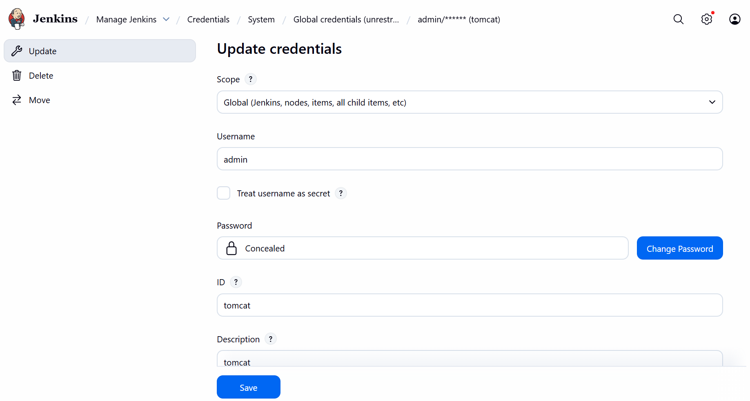

Important points verified above in all steps.
Notes to verify in future before building a pipeline.
Jenkins Setup for Your Jenkins file
1. Install Required Plugins
Go to Manage Jenkins → Plugins and ensure these are installed:
• Pipeline (Declarative + Scripted)
• Pipeline Utility Steps (for readMavenPom, findFiles)
• Nexus Artifact Uploader
• SonarQube Scanner for Jenkins
• Slack Notification

- Plugins

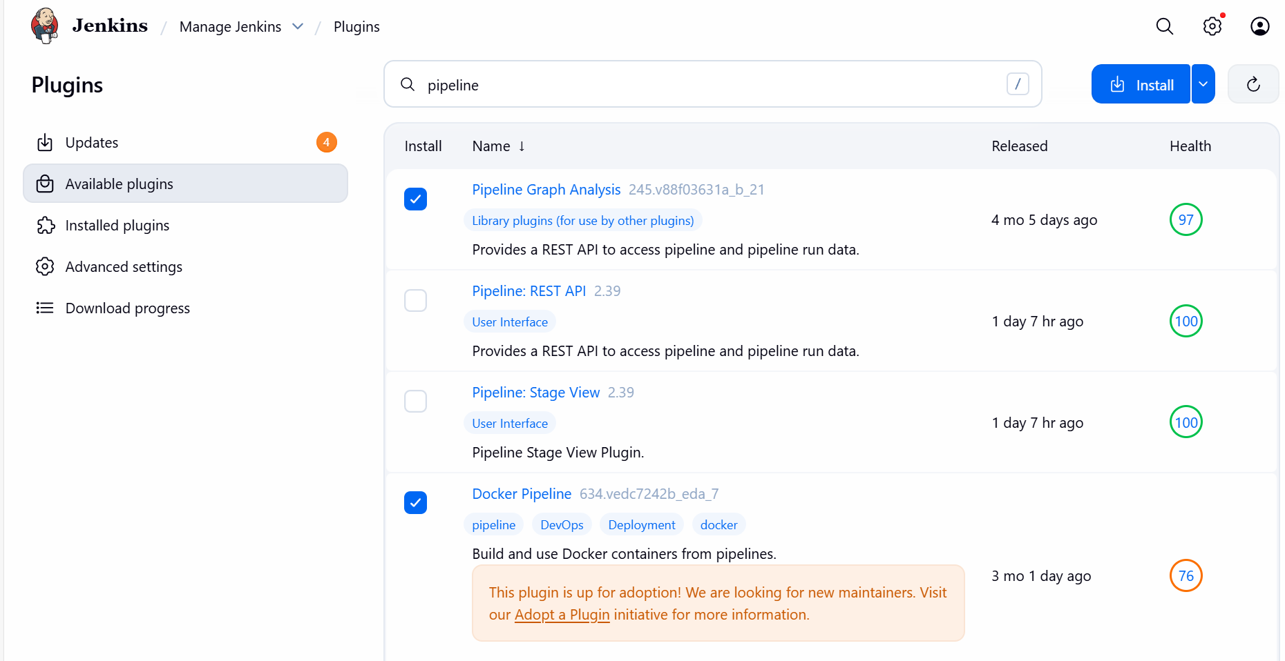

- Pipeline Utility steps (for readPom, findFiles)
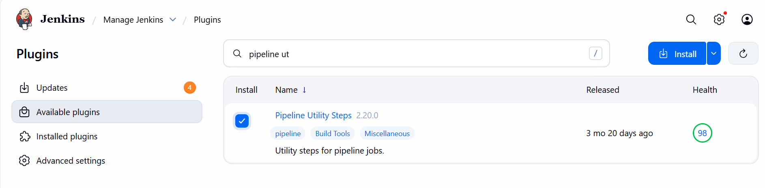
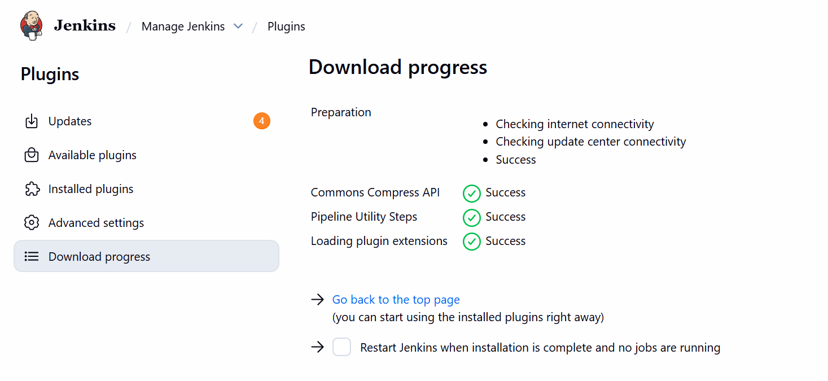
2. Configure Global Tools
Manage Jenkins → Global Tool Configuration
• Maven:
o Name: MVN_HOME (matches your Jenkinsfile)
o Install automatically or point to /usr/share/maven
• SonarQube Scanner:
o Name: sonar_scanner (matches your Jenkinsfile)
o Provide installation path or let Jenkins auto-install

3. Add Server Integrations
a) SonarQube
• Go to Manage Jenkins → Configure System → SonarQube servers
o Name: sonarqube-server (matches your Jenkinsfile)
o Add Server URL (e.g., http://<sonar-host>:9000)
o Add authentication token (create in SonarQube UI → My Account →
Security → Tokens)
b) Slack
• Go to Manage Jenkins → Configure System → Slack
o Workspace: your Slack team domain
o Integration token (from Slack App)
o Default channel: #jenkins-integration
• Test connection to ensure Jenkins can post.

4. Set Credentials
Manage Jenkins → Credentials → System → Global credentials
Add the following IDs (must match your Jenkinsfile):
• Nexus-server
o Type: Username with password
o Username: Nexus repo user
o Password: Nexus repo password
• tomcat
o Type: Username with password
o Username: Tomcat manager user
o Password: Tomcat manager password

Step 15: Create a new pipeline project in Jenkins GUI
- Name- Pipeline
- Project- Pipeline
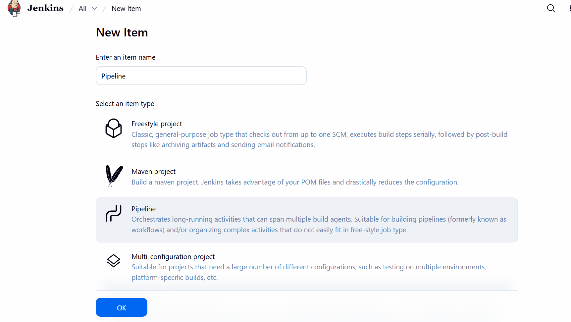

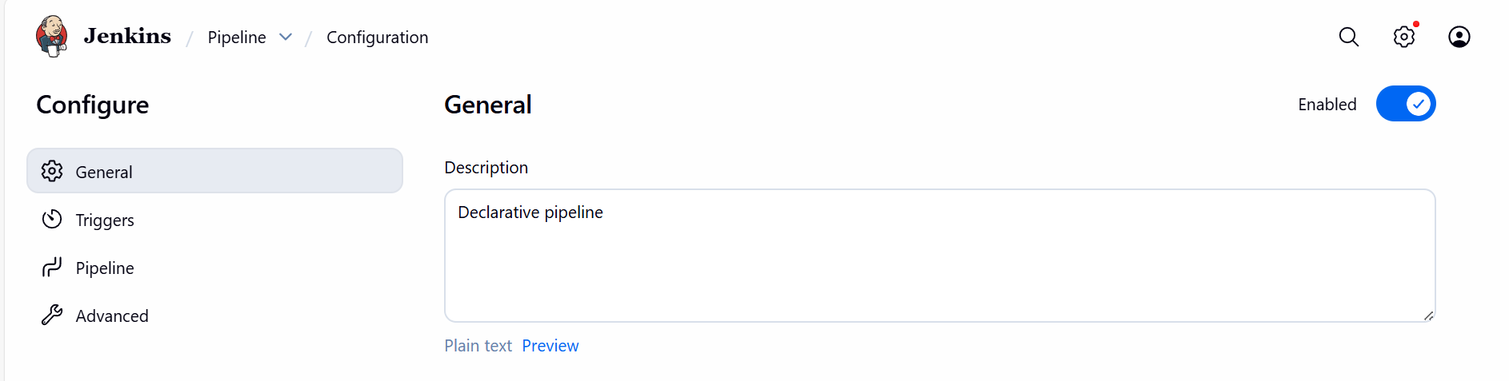

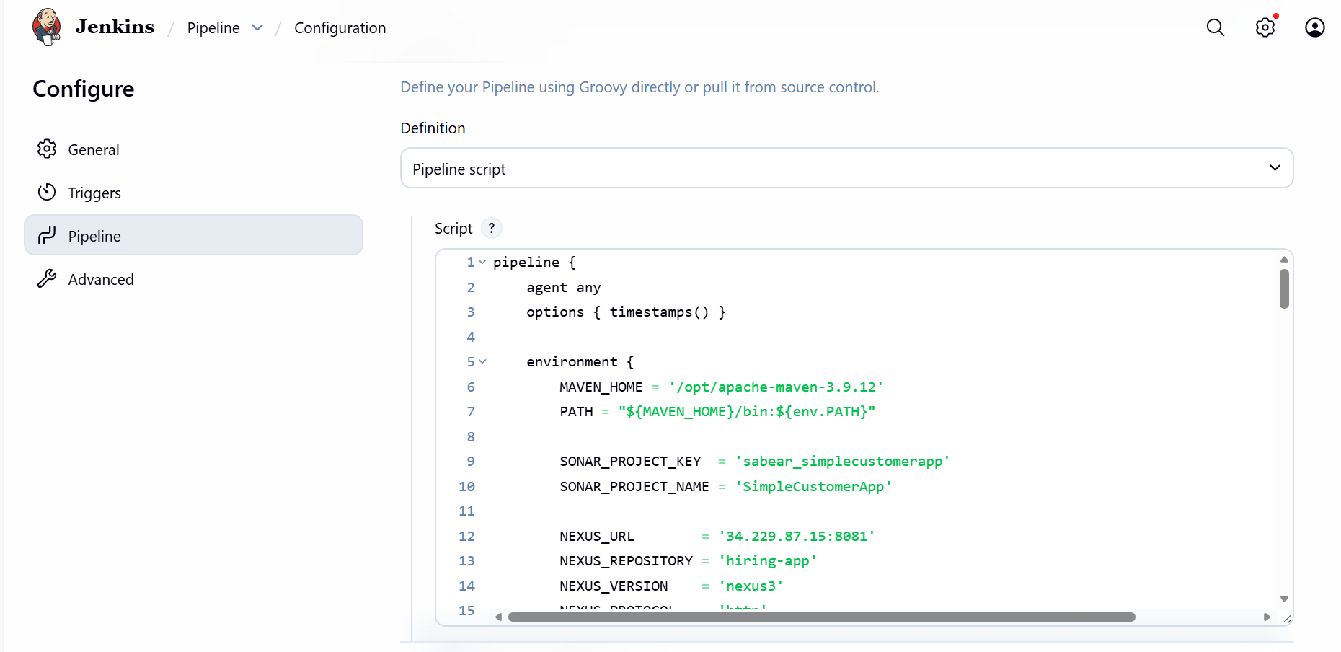

pipeline {
agent any
options { timestamps() }

environment {
MAVEN_HOME = '/opt/apache-maven-3.9.12'
PATH = "${MAVEN_HOME}/bin:${env.PATH}"

SONAR_PROJECT_KEY = 'sabear_simplecustomerapp'
SONAR_PROJECT_NAME = 'SimpleCustomerApp'

NEXUS_URL = '34.229.87.15:8081'
NEXUS_REPOSITORY = 'hiring-app'
NEXUS_VERSION = 'nexus3'
NEXUS_PROTOCOL = 'http'

TOMCAT_URL = 'http://3.88.51.237:8080'
}

stages {

stage('Notify Started') {
steps {
slackSend(
color: '#439FE0',
message: "Vicky | ${env.JOB_NAME} - #${env.BUILD_NUMBER} Started (<${env.BUILD_URL}|Open>)",
tokenCredentialId: 'Slack'
)
}
}

stage('Git Clone') {
steps {
git branch: 'feature-1.1',
url: 'https://github.com/saivicky123/sabear_simplecutomerapp.git'
}
}

stage('SonarQube Analysis') {
steps {
withSonarQubeEnv('sonar-server') {
sh """
${MAVEN_HOME}/bin/mvn clean verify \
org.sonarsource.scanner.maven:sonar-maven-plugin:3.11.0.3922:sonar \
-Dsonar.projectKey=${SONAR_PROJECT_KEY} \
-Dsonar.projectName=${SONAR_PROJECT_NAME}
"""
}
}
}

stage('Maven Build') {
steps {
sh "${MAVEN_HOME}/bin/mvn clean package -DskipTests"
}
}

stage('Nexus Upload') {
steps {
script {
def WAR_FILE = sh(
script: "find target -name '*.war' | head -n 1",
returnStdout: true
).trim()

nexusArtifactUploader(
nexusVersion: NEXUS_VERSION,
protocol: NEXUS_PROTOCOL,
nexusUrl: NEXUS_URL,
repository: NEXUS_REPOSITORY,
credentialsId: 'nexus_server',
groupId: 'com.javatpoint',
version: "${env.BUILD_NUMBER}-SNAPSHOT",
artifacts: [[
artifactId: 'SimpleCustomerApp',
classifier: '',
type: 'war',
file: WAR_FILE
]]
)
}
}
}

stage('Deploy to Tomcat') {
steps {
deploy adapters: [
tomcat9(
credentialsId: 'tomcat',
url: "${TOMCAT_URL}"
)
],
contextPath: 'sabear',
war: 'target/*.war'
}
}
}

post {
success {
slackSend(
color: 'good',
message: "Vicky | ${env.JOB_NAME} - #${env.BUILD_NUMBER} Success (<${env.BUILD_URL}|Open>)",
tokenCredentialId: 'Slack'
)
}

failure {
slackSend(
color: 'danger',
message: "Vicky | ${env.JOB_NAME} - #${env.BUILD_NUMBER} Failed (<${env.BUILD_URL}|Open>)",
tokenCredentialId: 'Slack'
)
}
}
}
Step 16: Build Now Success.
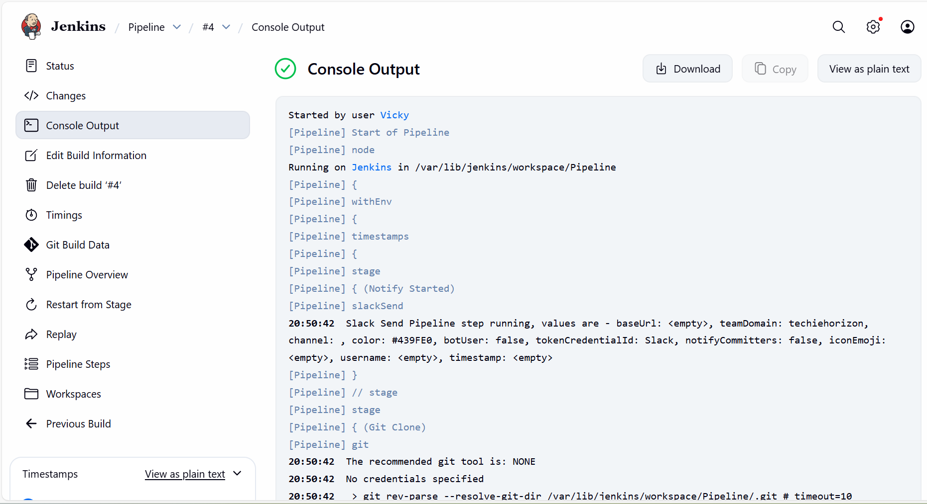
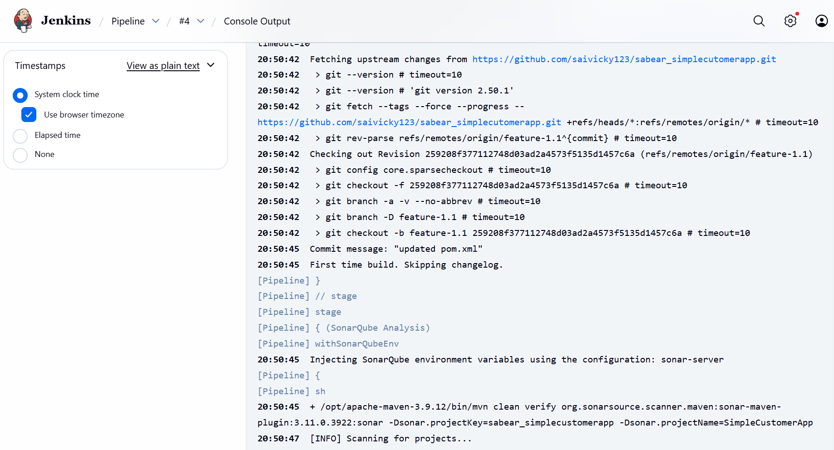

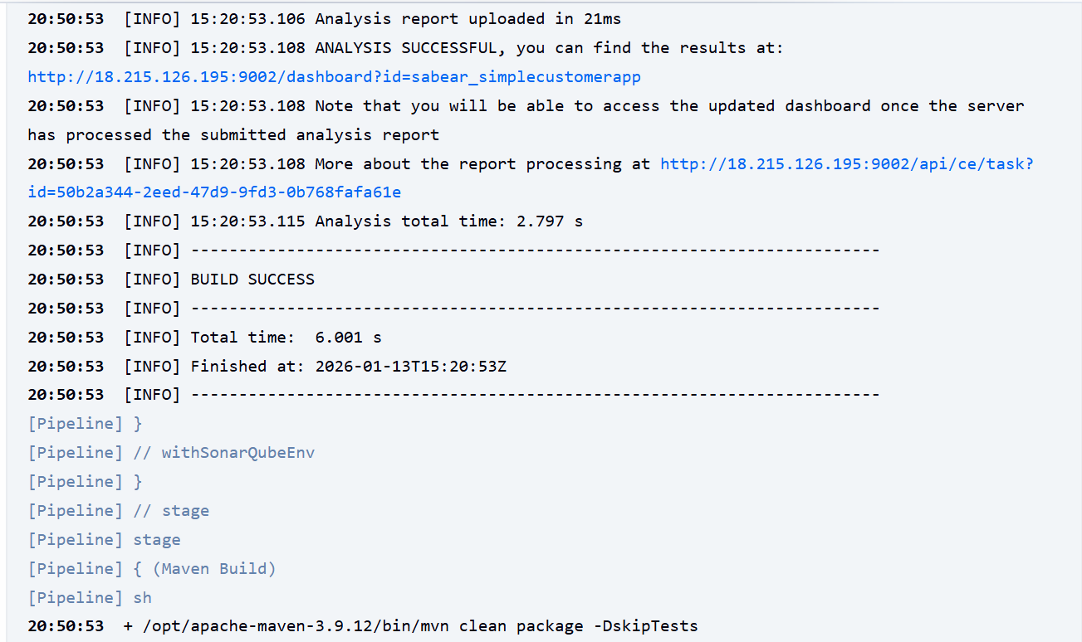
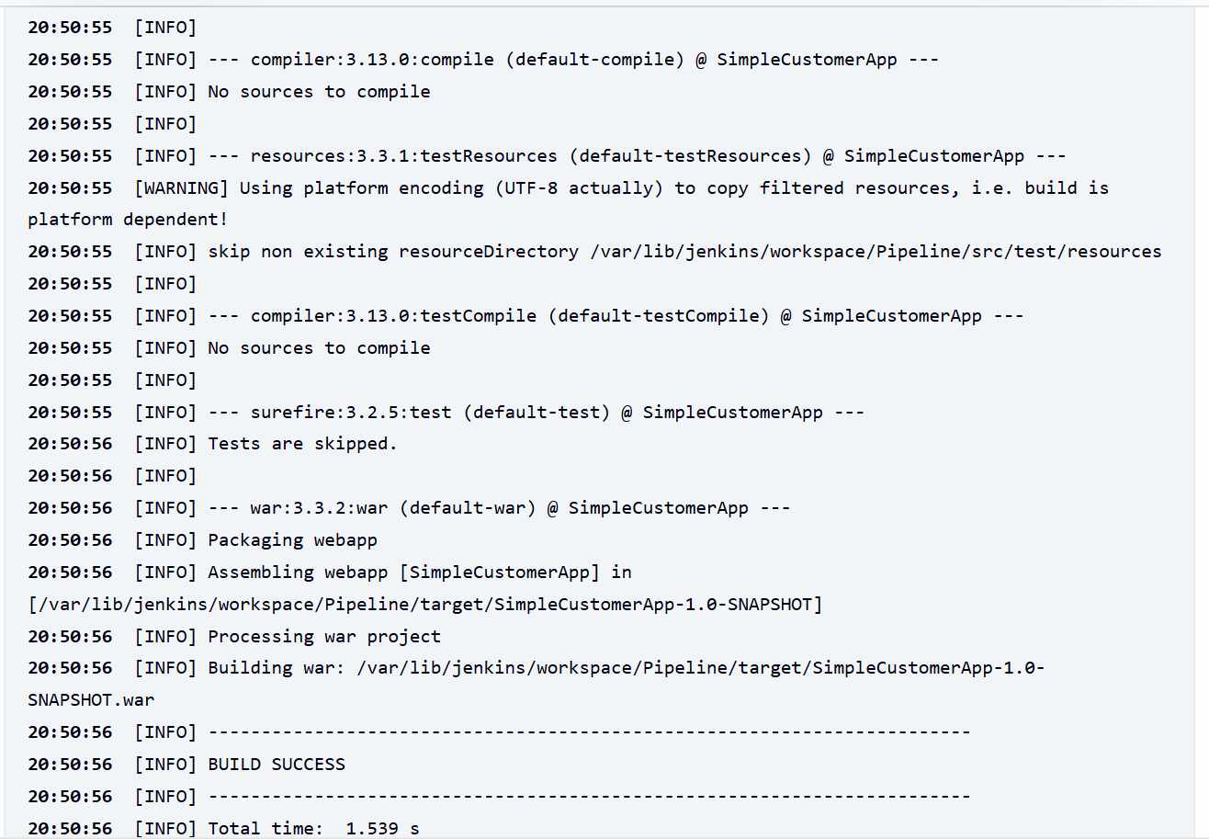
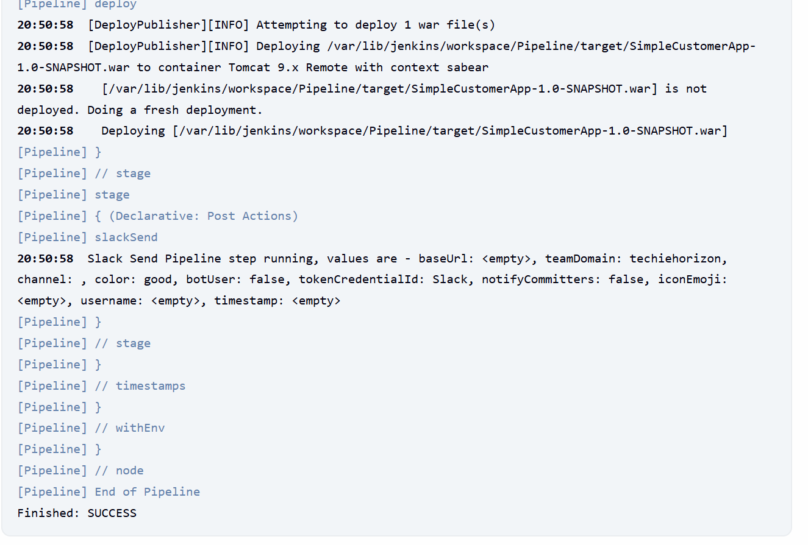

Issues faced:
- Sonarqube Installation Manage Jenkins
  - Credential ID has to match, not your login id.
- Sonar-Scanner sonar-scanner should have updated Sonarqube URL pasted in Jenkins server.
- Nexus Credential- Nexus credential id should be pasted in script, not login id.
- Tomcat Credential- Tomcat credential id should be pasted in script, not login id.
- Sonarqube script pasted in Pipeline failed- verified after reviewing GitHub repo.
- Pom.xml has a issue, so, using command below, I fixed the line and saved.
  - cd /var/lib/jenkins/workspace/Pipeline
  - nano pom.xml
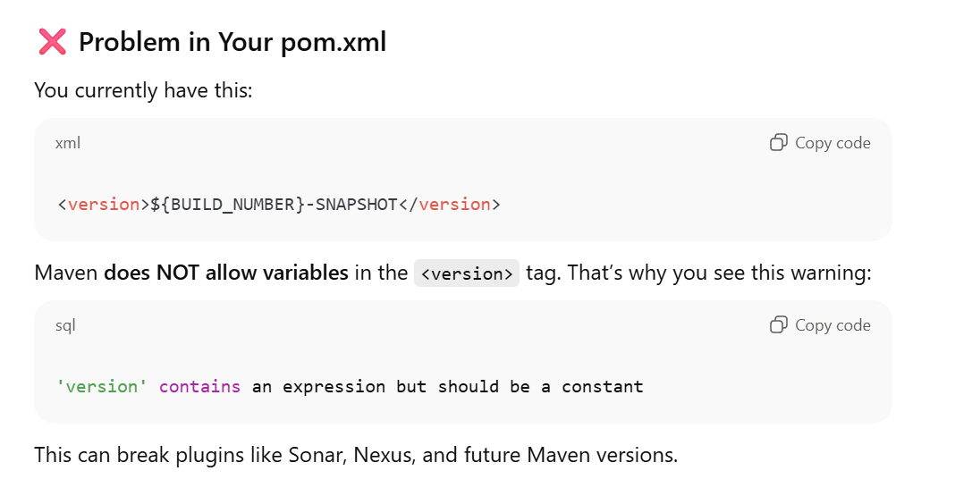
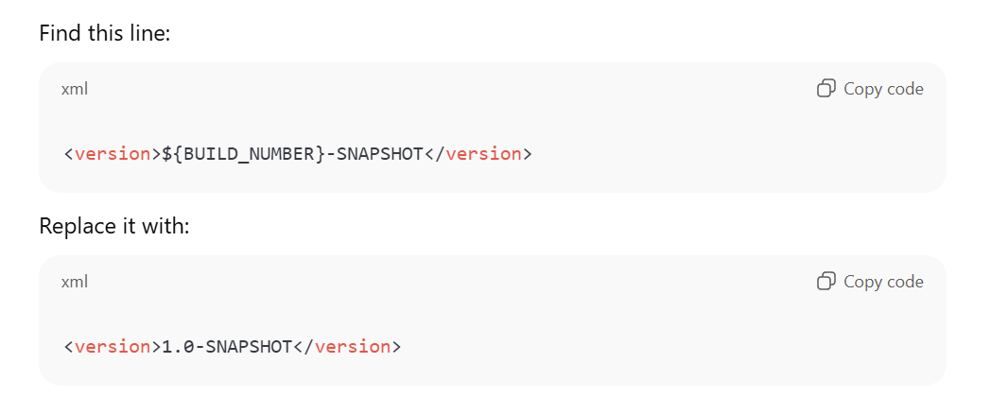

- Then, I didn’t had permission to update in the repo, so I forked the repo, generated a token in settings and updated in Jenkins server.

3. Setup a Jenkins CICD pipeline using Scripted pipeline using feature-1.1 branch. https://github.com/betawins/sabear_simplecutomerapp/tree/feature-1.1
stages:
Stage 1: Git Clone
Stage 2: SonarQube Integration
Stage 3: Maven Compilation
Stage 4: Nexus Artifactory
Stage 5: Slack Notification
Stage 6: Deploy On tomcat
Step by step Implementation:
Step 1:
Login into Jenkins GUI

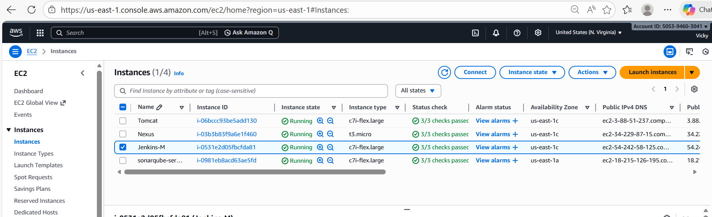
- Logged into Jenkins GUI
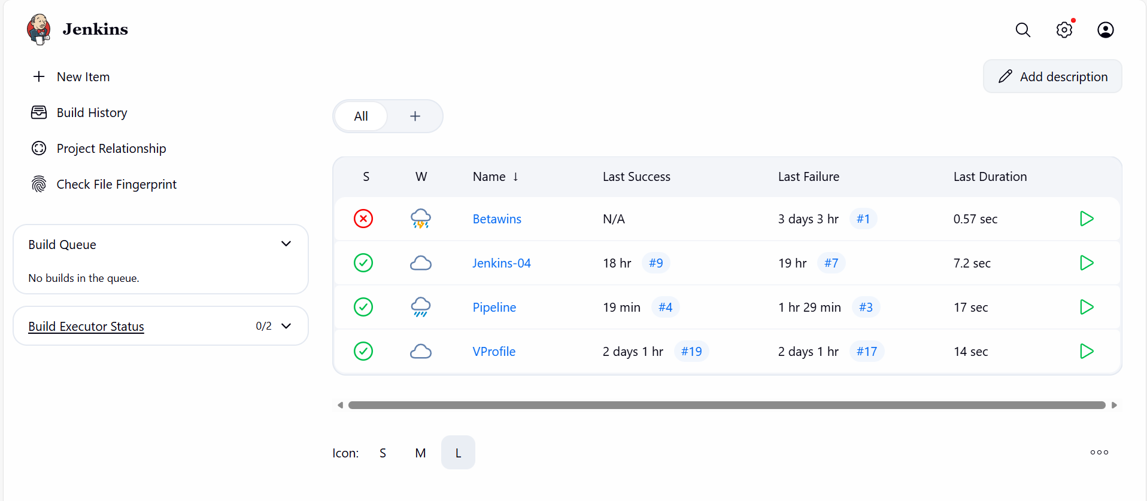

Step 2: Navigate to Manage Jenkins Plugins
Install a plugin called Stage view
Reason for installing this plugin is, after building, we can view the build in stages.
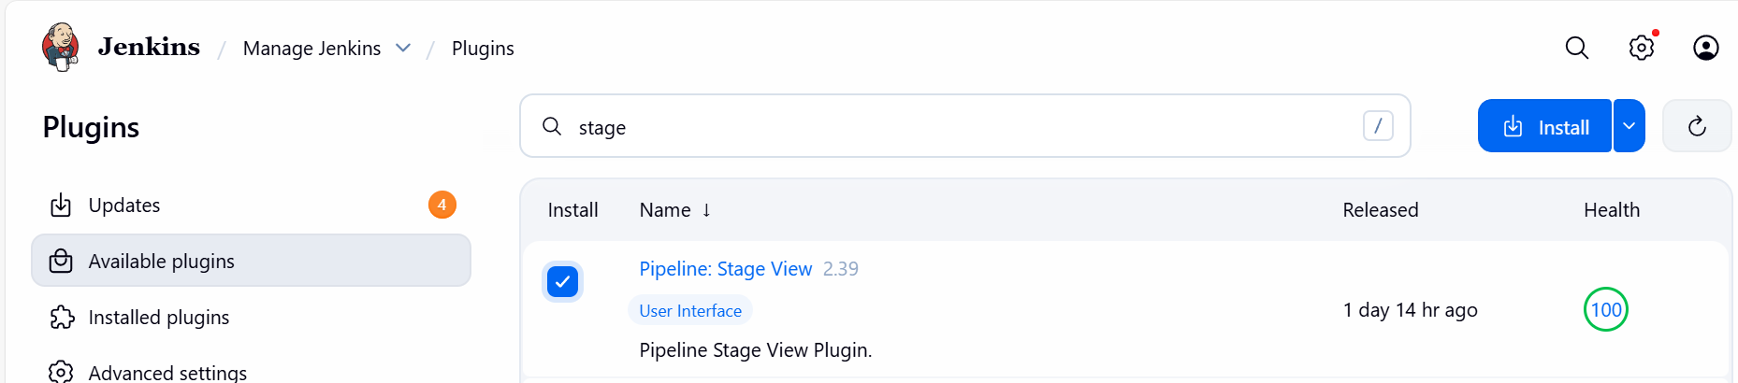

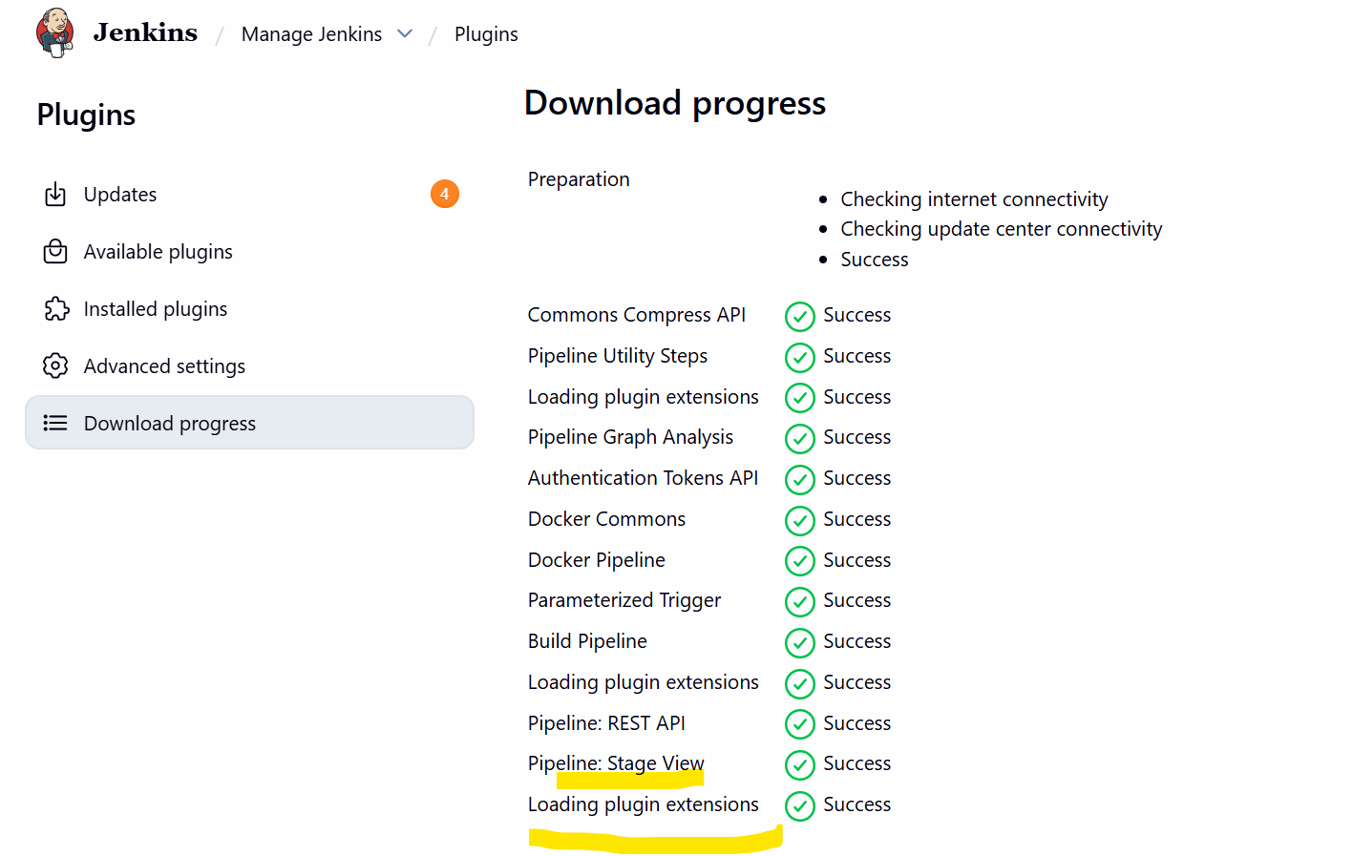

- This is my previous job executed.
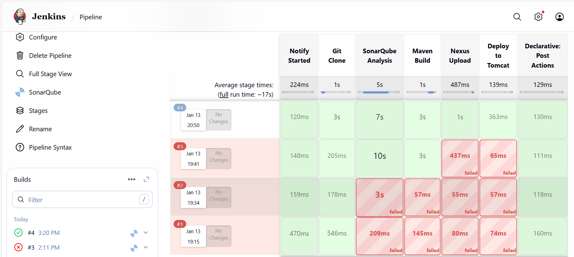

Step 3: Create a new job Scripted_pipeline
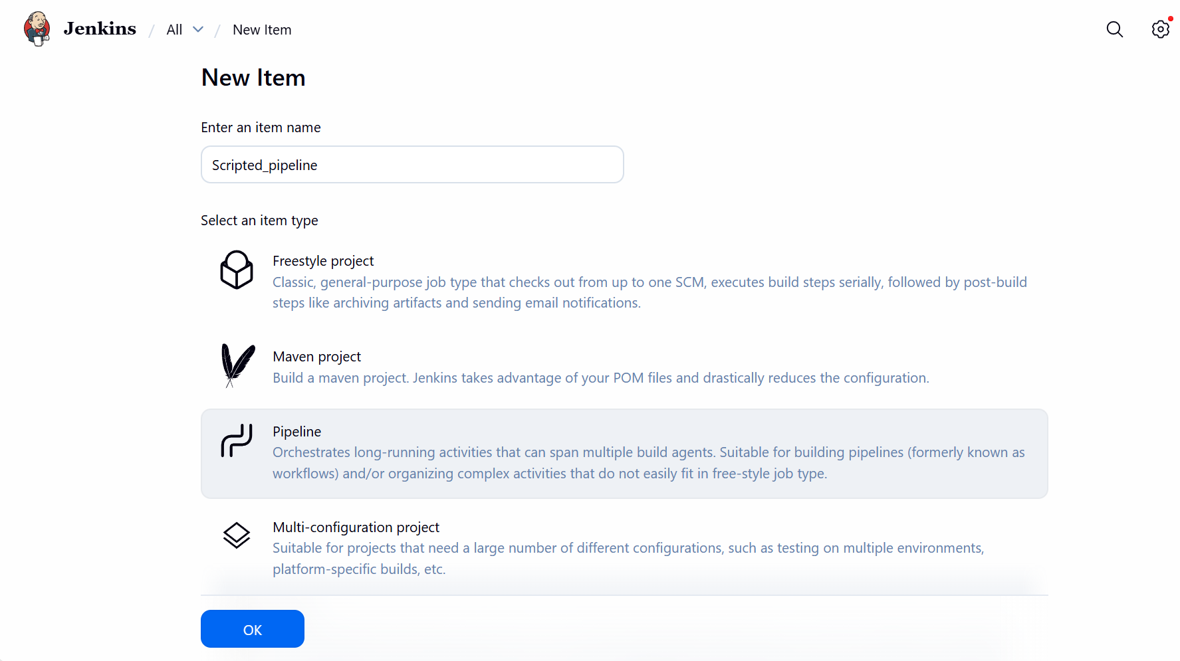

Step 4: Configure the Script in the pipeline below.
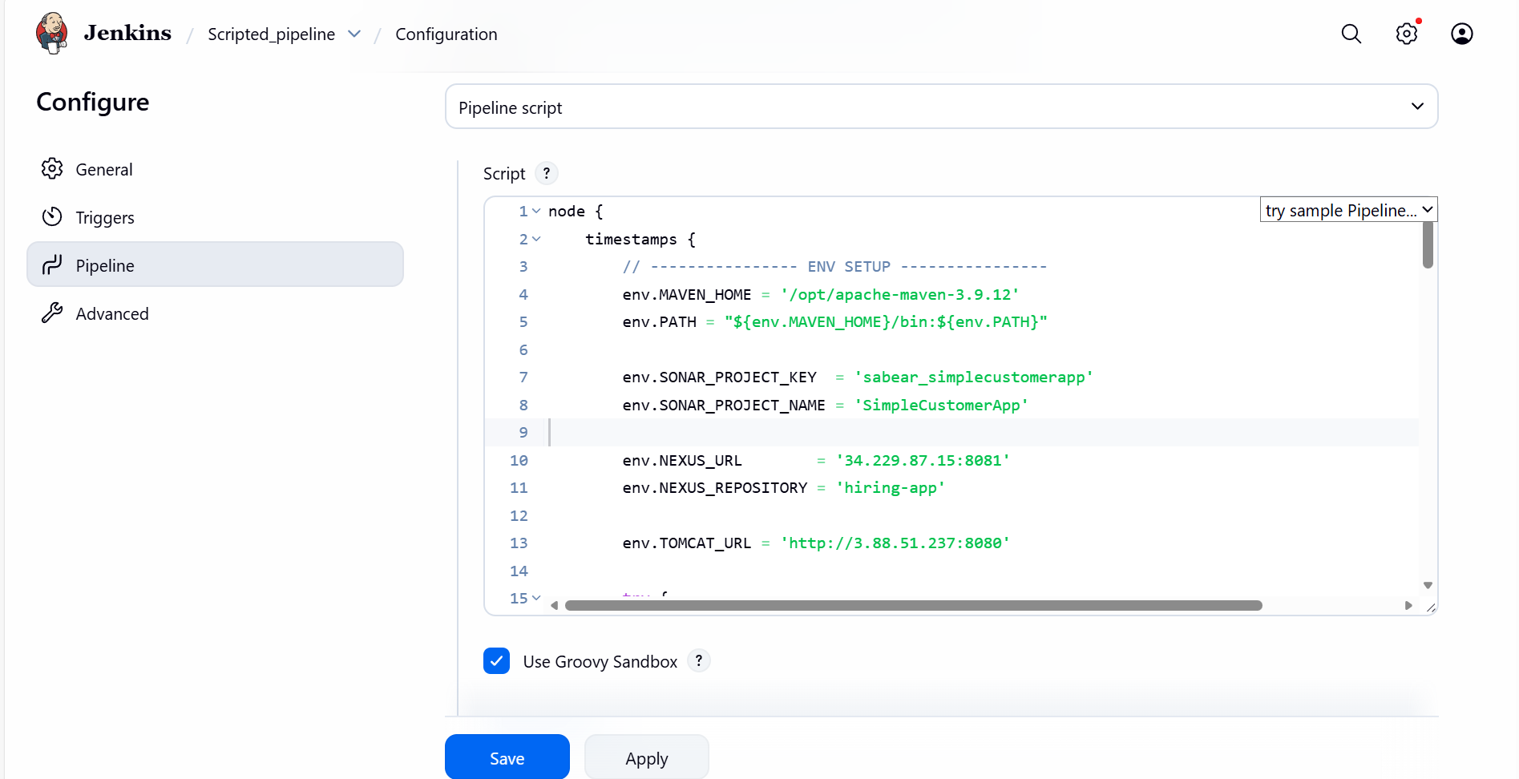

node {
timestamps {
// ---------------- ENV SETUP ----------------
env.MAVEN_HOME = '/opt/apache-maven-3.9.12'
env.PATH = "${env.MAVEN_HOME}/bin:${env.PATH}"

env.SONAR_PROJECT_KEY = 'sabear_simplecustomerapp'
env.SONAR_PROJECT_NAME = 'SimpleCustomerApp'

env.NEXUS_URL = '34.229.87.15:8081'
env.NEXUS_REPOSITORY = 'hiring-app'

env.TOMCAT_URL = 'http://3.88.51.237:8080'

try {
// ---------------- SLACK : STARTED ----------------
stage('Slack Notification - Started') {
slackSend(
color: '#439FE0',
message: "Vicky | ${env.JOB_NAME} - #${env.BUILD_NUMBER} Started (<${env.BUILD_URL}|Open>)",
tokenCredentialId: 'Slack'
)
}

// ---------------- GIT CLONE ----------------
stage('Git Clone') {
git branch: 'feature-1.1',
url: 'https://github.com/saivicky123/sabear_simplecutomerapp.git'
}

// ---------------- SONARQUBE ----------------
stage('SonarQube Integration') {
withSonarQubeEnv('sonar-server') {
sh """
${env.MAVEN_HOME}/bin/mvn clean verify \
org.sonarsource.scanner.maven:sonar-maven-plugin:3.11.0.3922:sonar \
-Dsonar.projectKey=${env.SONAR_PROJECT_KEY} \
-Dsonar.projectName=${env.SONAR_PROJECT_NAME}
"""
}
}

// ---------------- MAVEN BUILD ----------------
stage('Maven Compilation') {
sh "${env.MAVEN_HOME}/bin/mvn clean package -DskipTests"
}

// ---------------- NEXUS UPLOAD ----------------
stage('Nexus Artifactory') {
def warFile = sh(
script: "find target -name '*.war' | head -n 1",
returnStdout: true
).trim()

nexusArtifactUploader(
nexusVersion: 'nexus3',
protocol: 'http',
nexusUrl: env.NEXUS_URL,
repository: env.NEXUS_REPOSITORY,
credentialsId: 'nexus_server',
groupId: 'com.javatpoint',
version: "${env.BUILD_NUMBER}-SNAPSHOT",
artifacts: [[
artifactId: 'SimpleCustomerApp',
classifier: '',
type: 'war',
file: warFile
]]
)
}

// ---------------- TOMCAT DEPLOY ----------------
stage('Deploy On Tomcat') {
deploy adapters: [
tomcat9(
credentialsId: 'tomcat',
url: env.TOMCAT_URL
)
],
contextPath: 'sabear',
war: 'target/*.war'
}

// ---------------- SLACK : SUCCESS ----------------
stage('Slack Notification - Success') {
slackSend(
color: 'good',
message: "Vicky | ${env.JOB_NAME} - #${env.BUILD_NUMBER} Success (<${env.BUILD_URL}|Open>)",
tokenCredentialId: 'Slack'
)
}

} catch (err) {
// ---------------- SLACK : FAILURE ----------------
slackSend(
color: 'danger',
message: "Vicky | ${env.JOB_NAME} - #${env.BUILD_NUMBER} Failed (<${env.BUILD_URL}|Open>)",
tokenCredentialId: 'Slack'
)
throw err
}
}
}

Step 5: Build Now
- Success – the pipeline was built as expected.

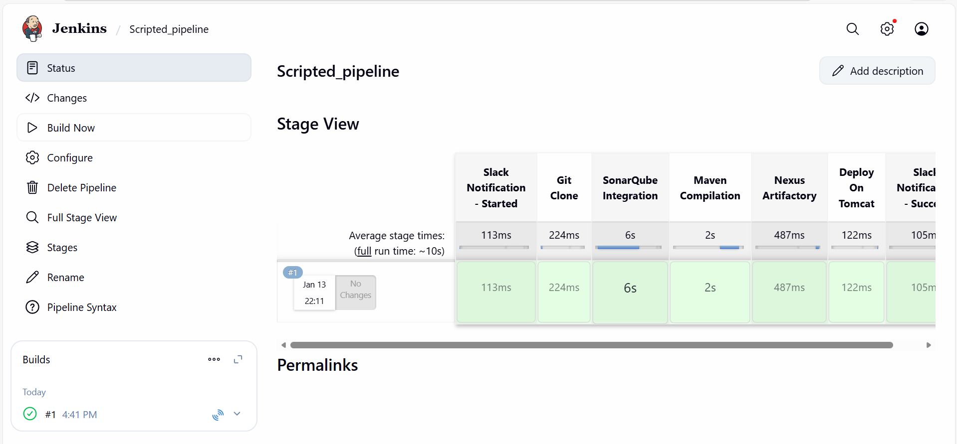
- Verified Console output as well.
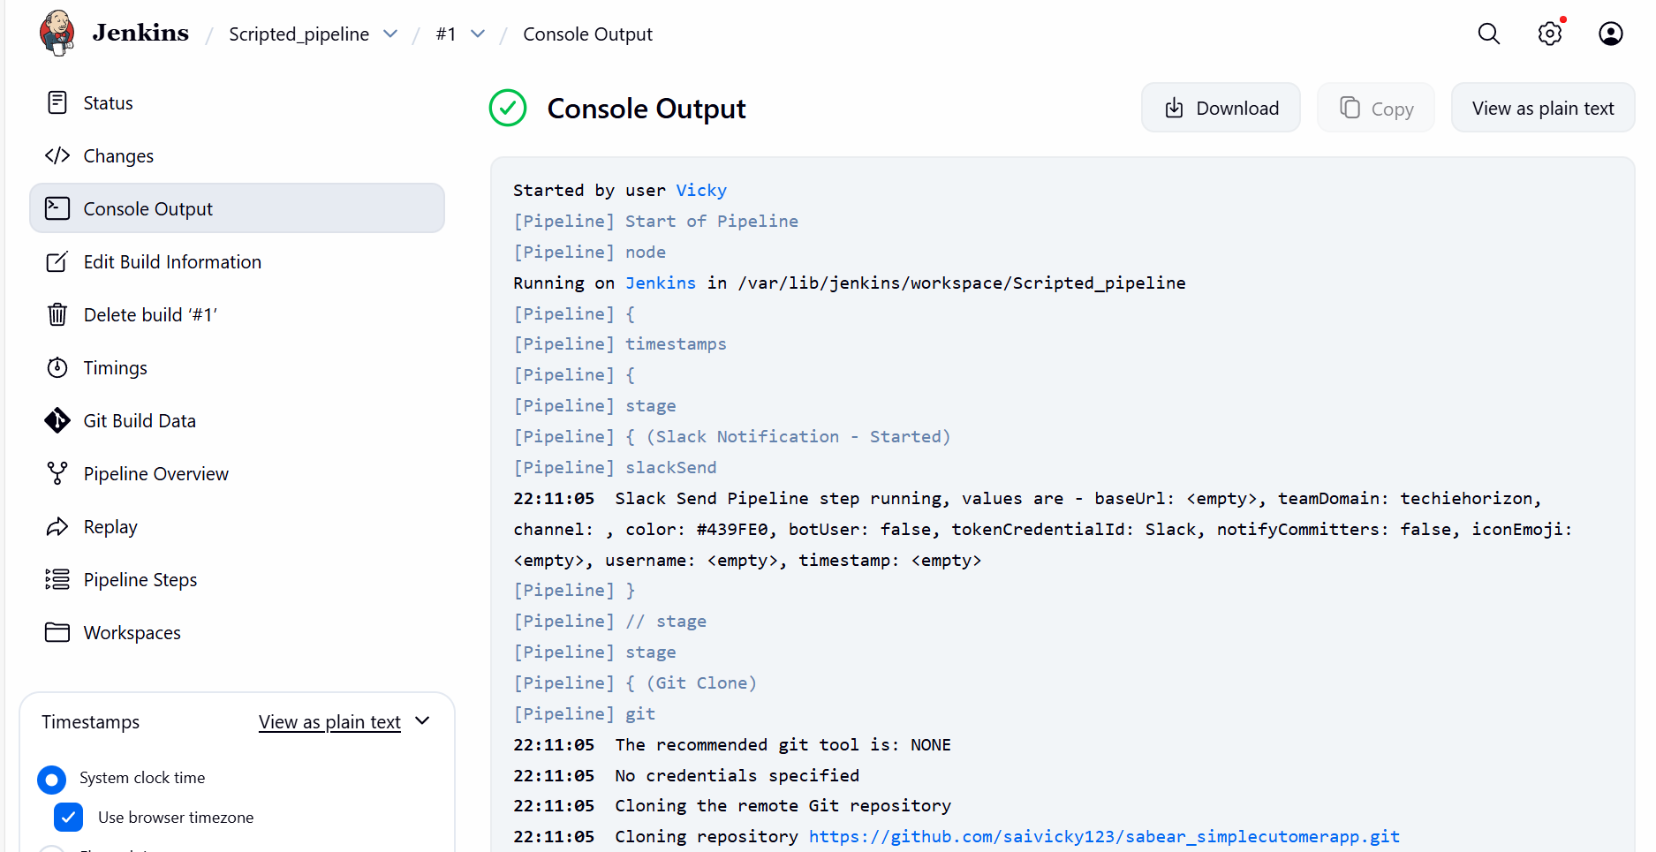

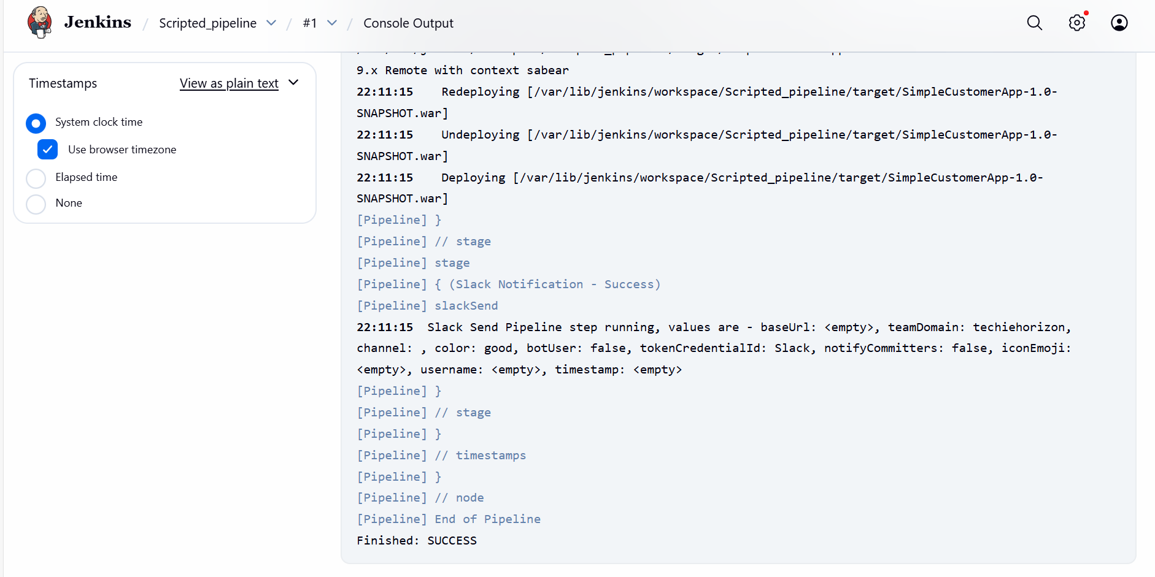
Step 6: We got notified the built status in Slack integration as well.
Stages completed.
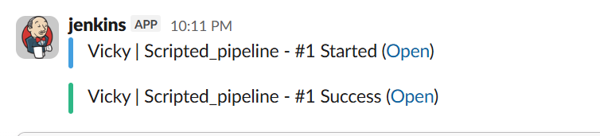
4. Write sample skeleton of pipelines.
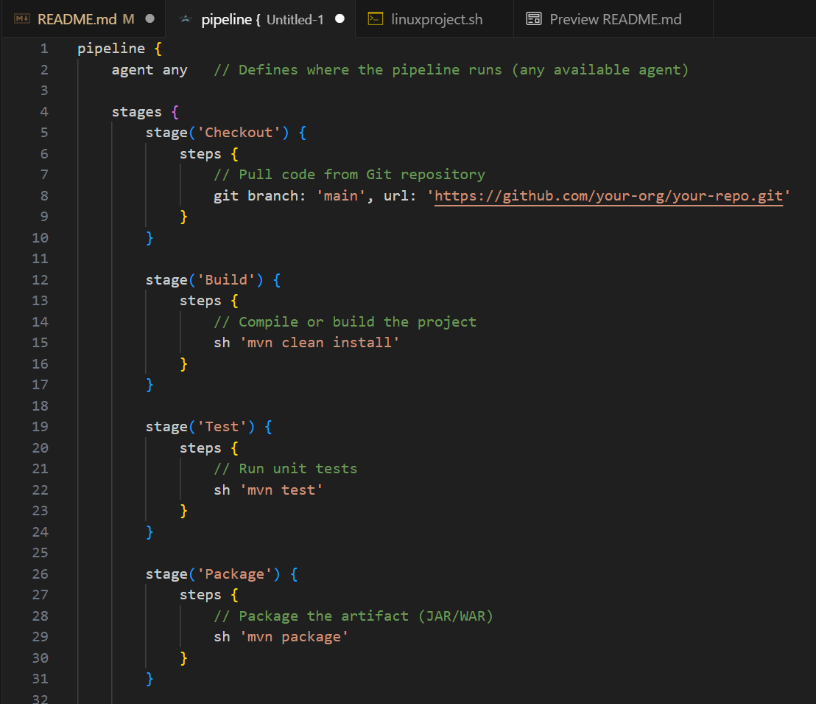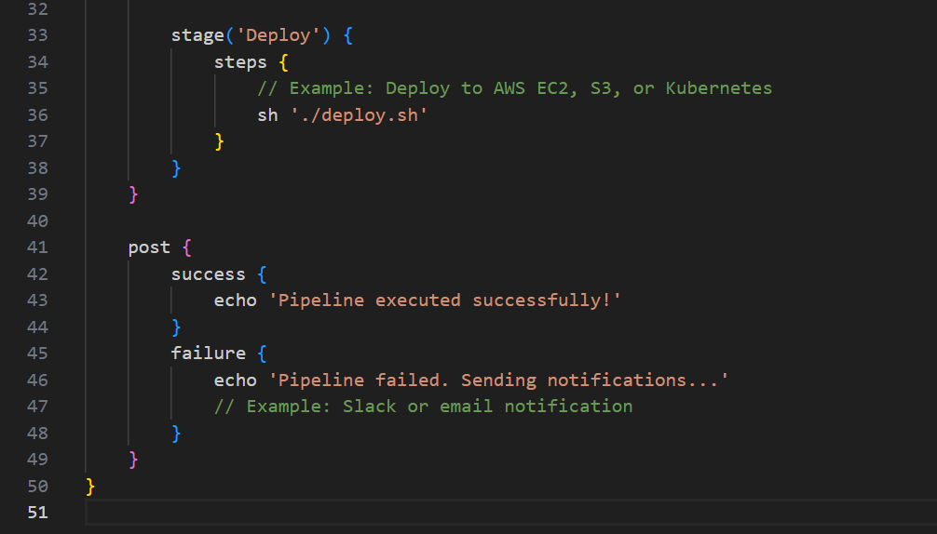
- Declarative Pipeline – Skeleton

pipeline {
agent any // Defines where the pipeline runs (any available agent)

stages {
stage('Checkout') {
steps {
// Pull code from Git repository
git branch: 'main', url: 'https://github.com/your-org/your-repo.git'
}
}

stage('Build') {
steps {
// Compile or build the project
sh 'mvn clean install'
}
}

stage('SonarQube Analysis') {
steps {
withSonarQubeEnv('sonarqube-server')
sh 'sonar-scanner'
}
}

stage('Package') {
steps {
// Package the artifact (JAR/WAR)
sh 'mvn package'
}
}

stage('Deploy') {
steps {
// Example: Deploy to AWS EC2, S3, or Kubernetes
sh './deploy.sh'
}
}
}

post {
success {
echo 'Pipeline executed successfully!'
}
failure {
echo 'Pipeline failed. Sending notifications...'
// Example: Slack or email notification
}
}
}

2) Scripted Pipeline – Skeleton
node {
stage('Git Clone') {
git 'https://github.com/your-repo/sample-app.git'
}
stage('Build') {
sh 'mvn clean install'
}
stage('SonarQube Analysis') {
withSonarQubeEnv('sonarqube-server') {
sh 'sonar-scanner'
}
}
stage('Deploy') {
sh 'cp target/*.war /opt/tomcat/webapps/'
}
}
Conclusion for scripted:
Scripted pipeline uses Groovy scripting and provides more flexibility and control.

5. Create a parameterized job in Jenkins. https://github.com/betawins/spring3-mvc-maven-xml-hello-world-1.git

Objective:
The objective of this task is to create a parameterized job in Jenkins GUI to make the CI/CD pipelines flexible and reusable. By using parameters, we can use a single item or job to:
- Select Branches: Build any Git branch or tag dynamically.
- Target Environments: Choose between DEV, QA, or PROD at runtime.
- Toggle Features: Decide whether to run specific stages, like SonarQube or Nexus uploads, using checkboxes.

Step by step Implementation:
Step 1: Navigate to Jenkins GUI
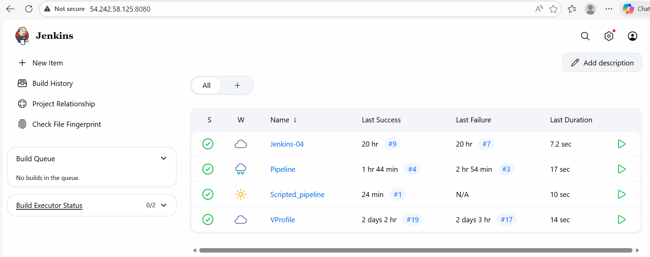

Step 2: Create a new job named- Parameter-job
Create and save.
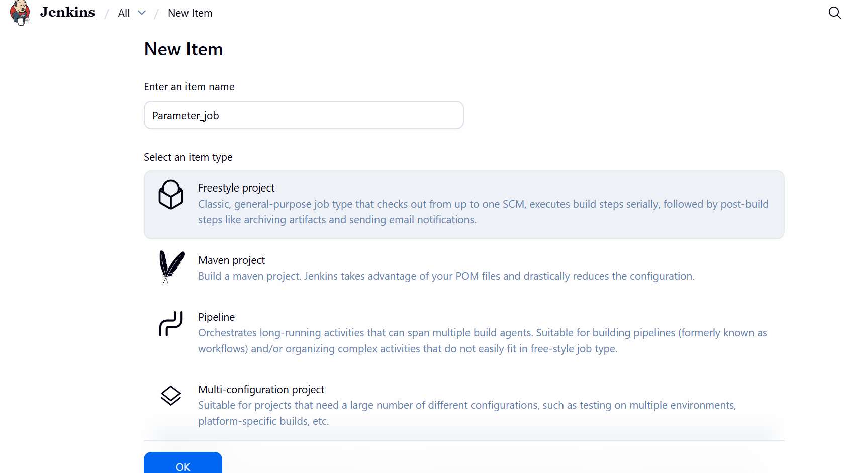

Step 3: Create a new job in pipeline- Parameter_job and configure the job
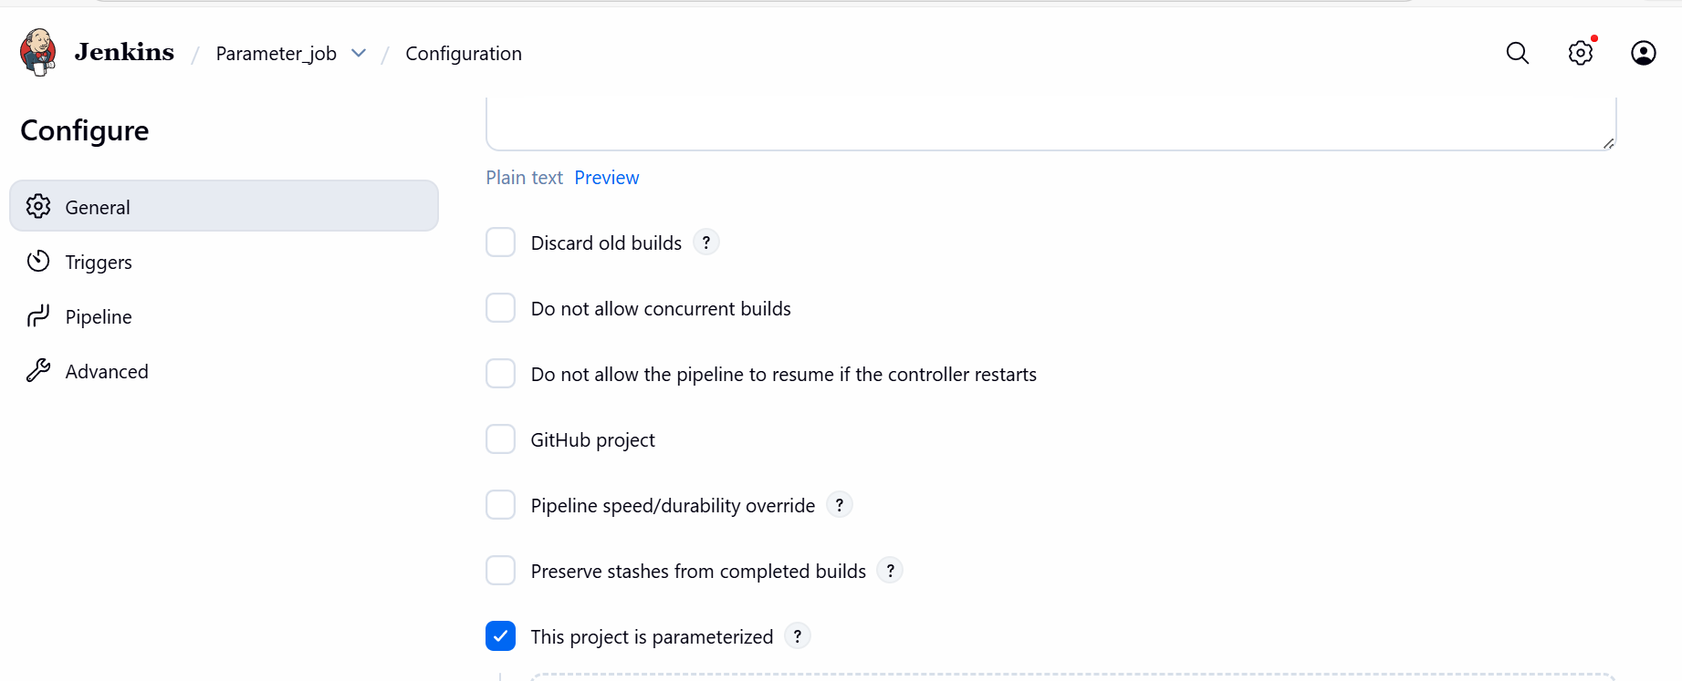

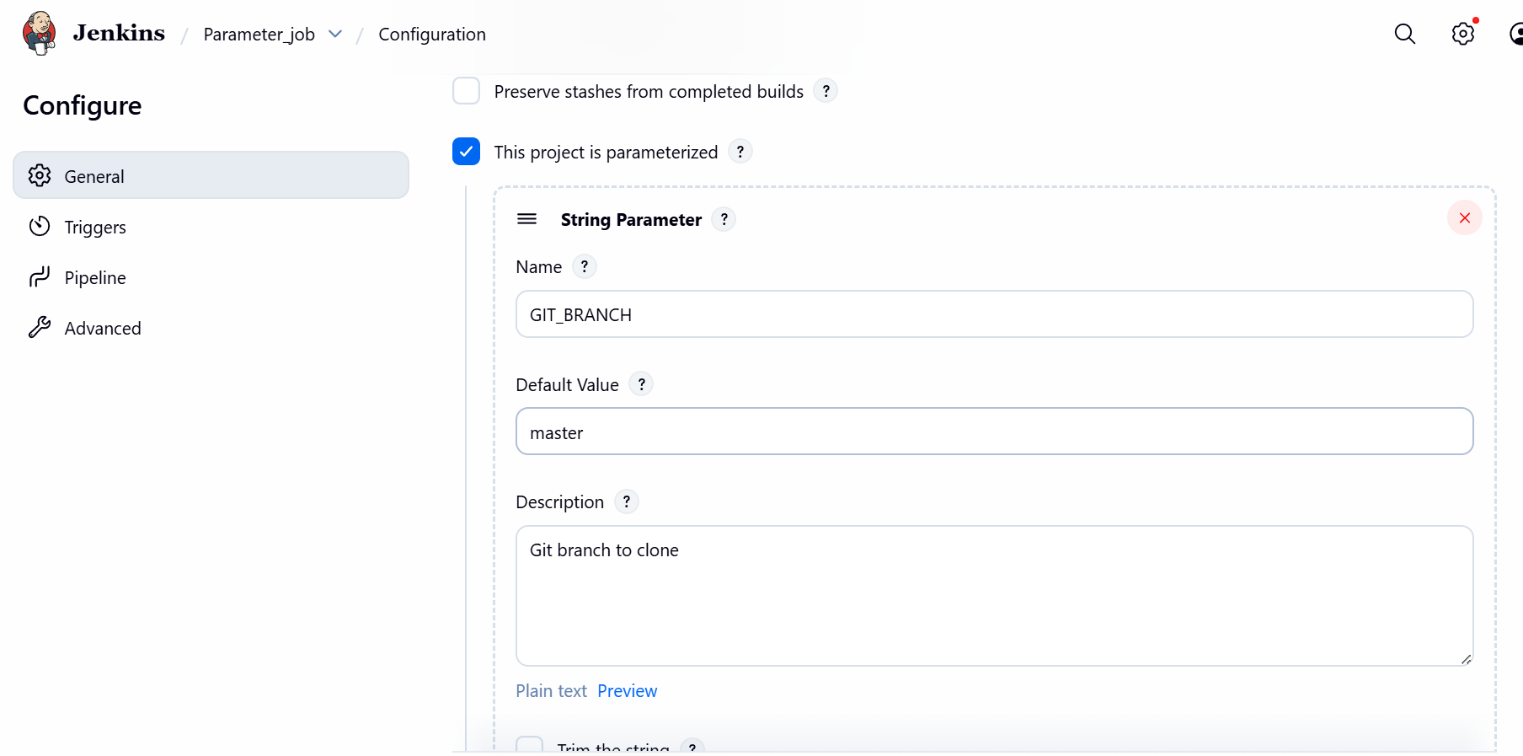
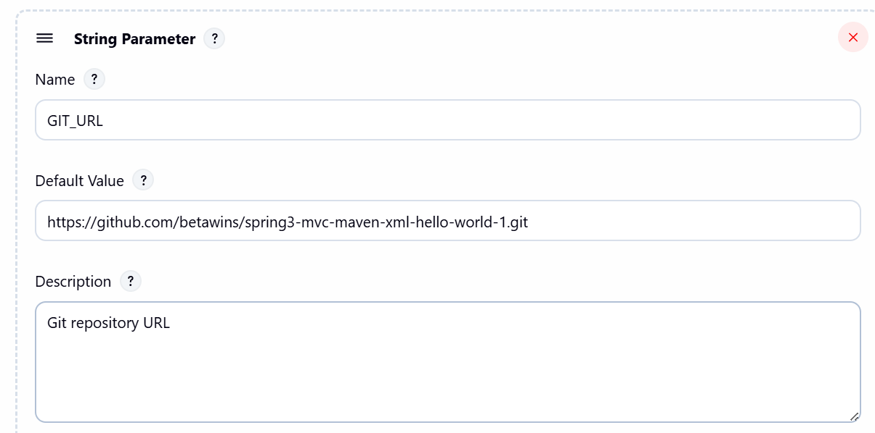

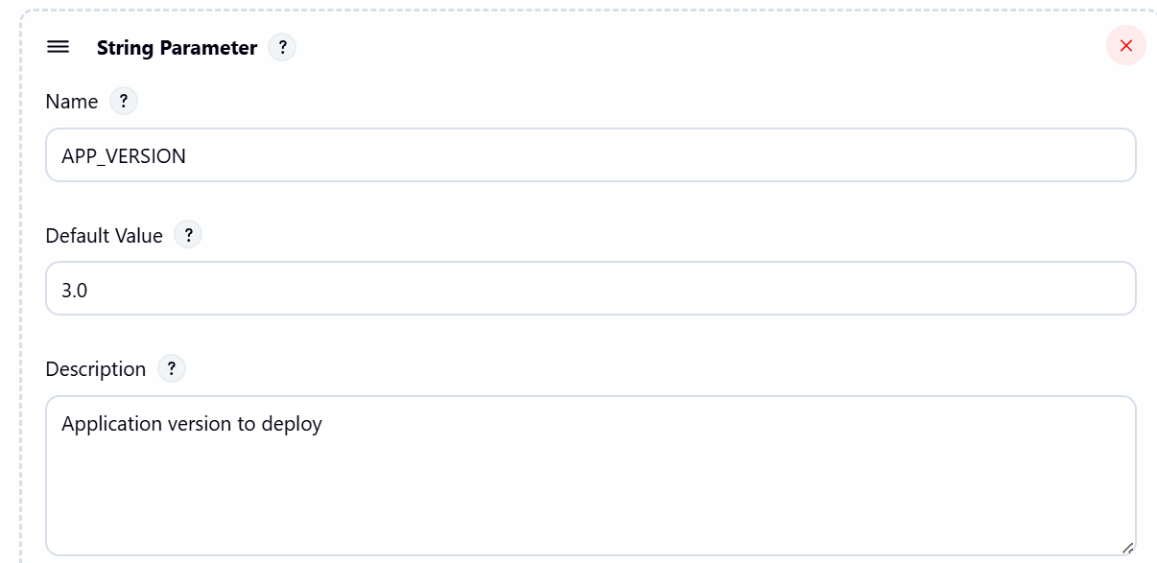

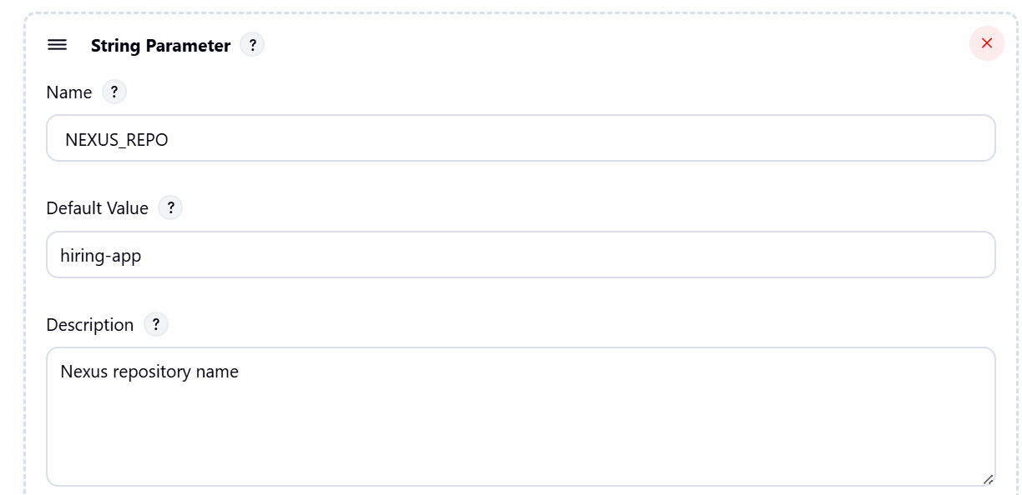

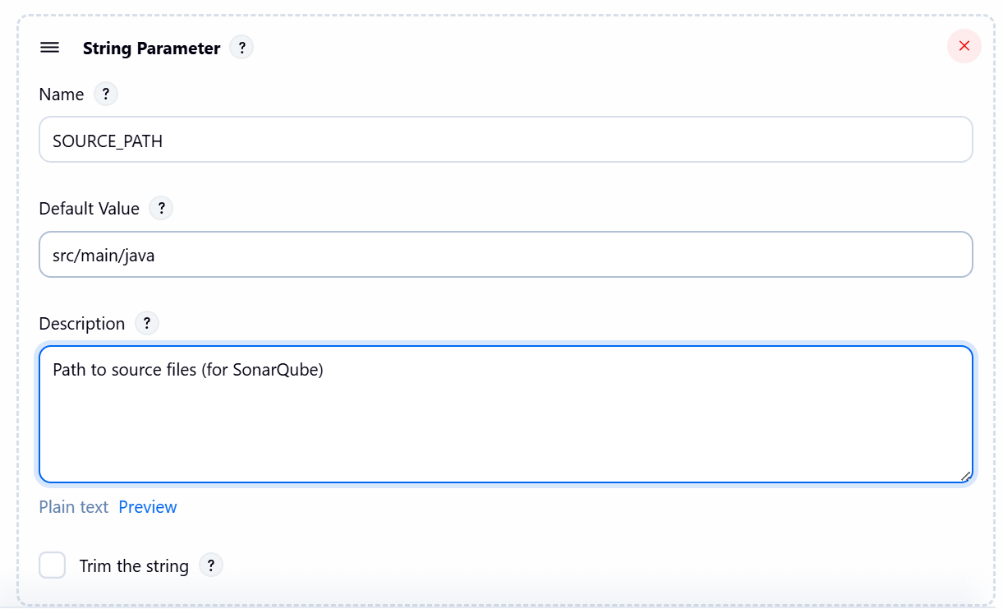

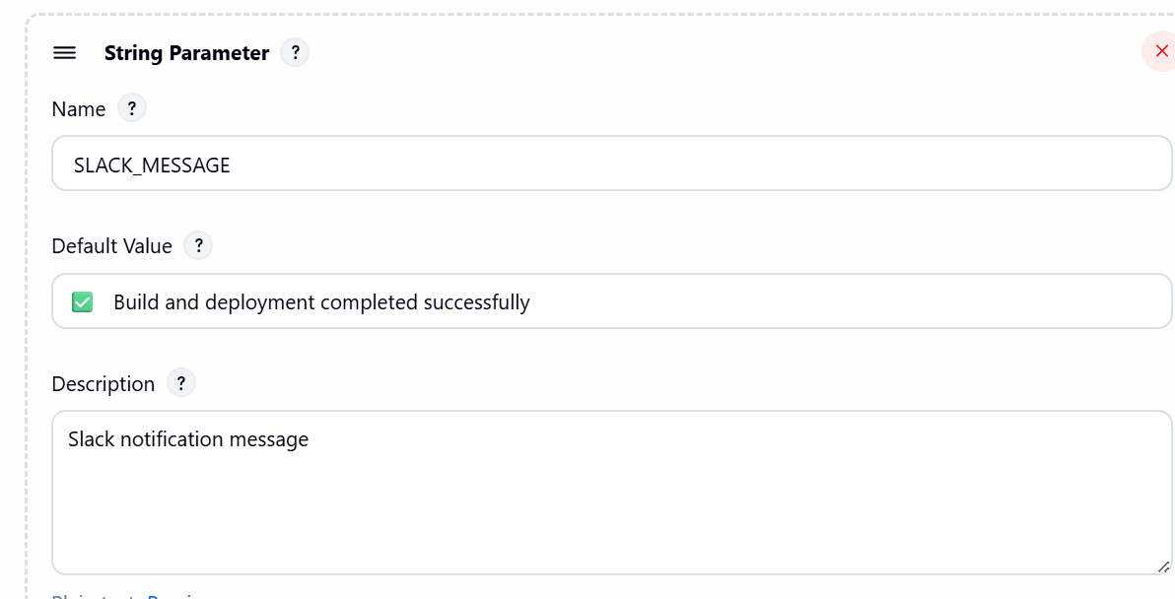

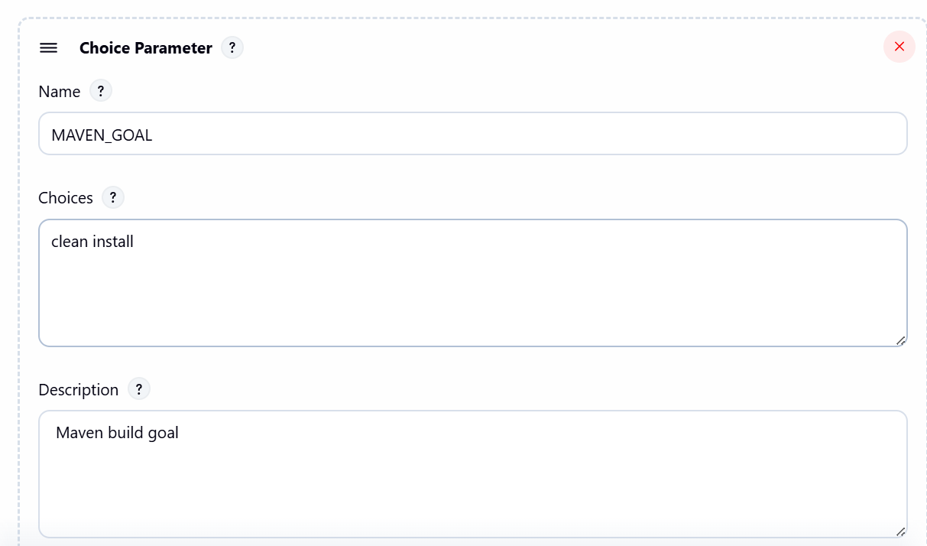

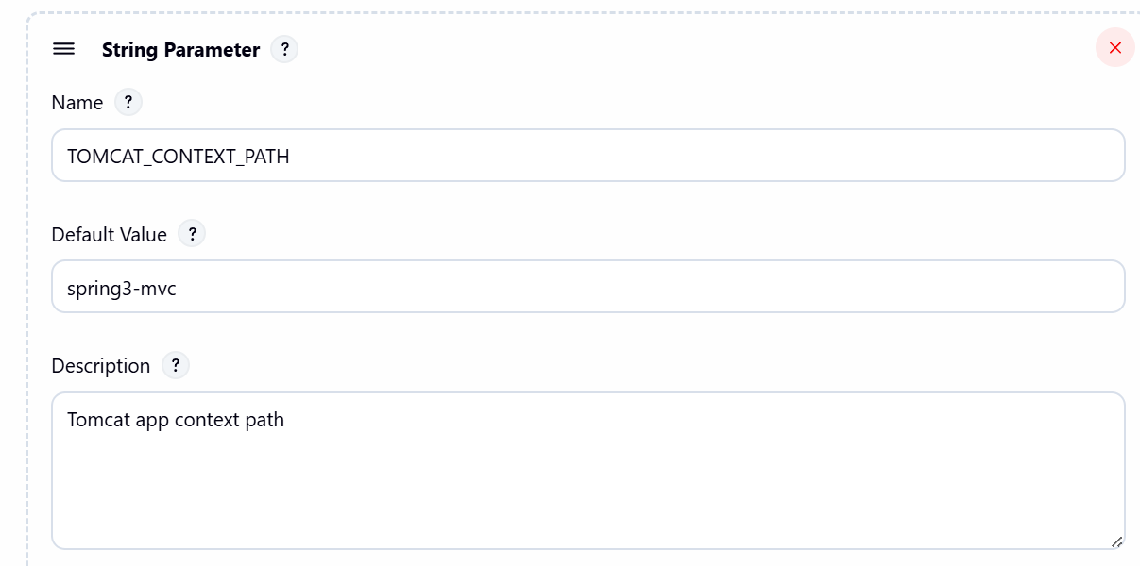

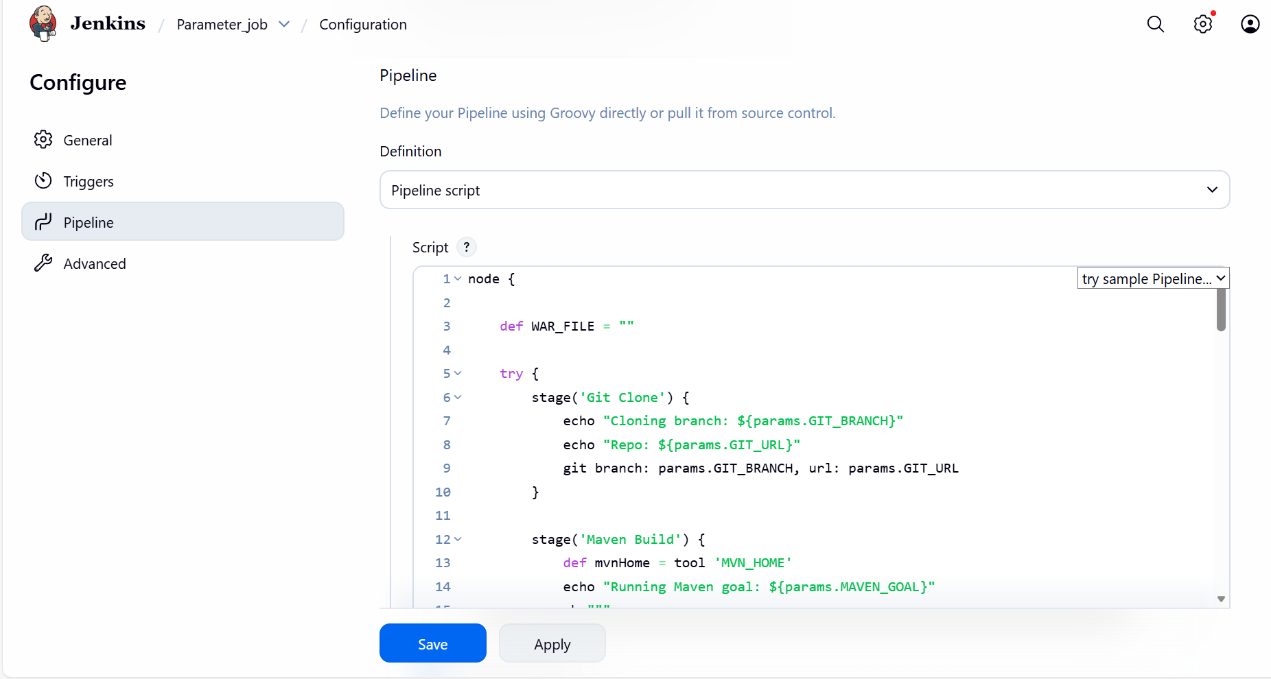

Pipeline below:
node {

def WAR_FILE = ""

try {
stage('Git Clone') {
echo "Cloning branch: ${params.GIT_BRANCH}"
echo "Repo: ${params.GIT_URL}"
git branch: params.GIT_BRANCH, url: params.GIT_URL
}

stage('Maven Build') {
def mvnHome = tool 'MVN_HOME'
echo "Running Maven goal: ${params.MAVEN_GOAL}"
sh """
${mvnHome}/bin/mvn ${params.MAVEN_GOAL}
"""
}

stage('Detect WAR File') {
WAR_FILE = sh(
script: "find target -name '*.war' | head -n 1",
returnStdout: true
).trim()

if (!WAR_FILE) {
error "WAR file not found!"
}

echo "Detected WAR: ${WAR_FILE}"
}

stage('SonarQube Analysis') {
withSonarQubeEnv('sonar-server') {
sh """
mvn sonar:sonar \
-Dsonar.projectKey=Sabear \
-Dsonar.projectName=Sabear \
-Dsonar.projectVersion=${params.APP_VERSION}
"""
}
}

stage('Upload to Nexus') {
nexusArtifactUploader(
nexusVersion: 'nexus3',
protocol: 'http',
nexusUrl: '34.229.87.15:8081',
repository: params.NEXUS_REPO,
credentialsId: 'nexus_server',
groupId: 'com.javatpoint',
version: params.APP_VERSION,
artifacts: [[
artifactId: 'SimpleCustomerApp',
classifier: '',
file: WAR_FILE,
type: 'war'
]]
)
}

stage('Deploy to Tomcat') {
deploy adapters: [
tomcat9(
credentialsId: 'tomcat',
url: 'http://3.88.51.237:8080'
)
],
contextPath: params.TOMCAT_CONTEXT_PATH,
war: WAR_FILE
}

stage('Slack Notification - Success') {
slackSend(
channel: '#jenkins-integration',
color: 'good',
message: "✅ ${params.SLACK_MESSAGE}\nJob: ${env.JOB_NAME}\nBuild: #${env.BUILD_NUMBER}"
)
}

} catch (err) {

slackSend(
channel: '#jenkins-integration',
color: 'danger',
message: "❌ BUILD FAILED: ${env.JOB_NAME} #${env.BUILD_NUMBER}"
)

throw err
}
}

Final step: Build Now.
Failed- The pom.xml file has java version 6.0 and below, but my Java-version is newer version installed in Jenkins server.
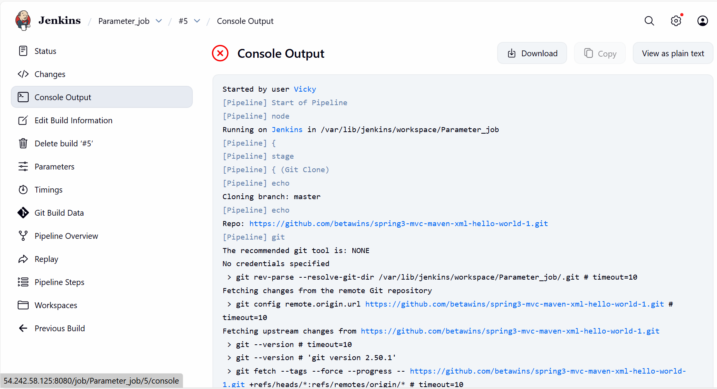
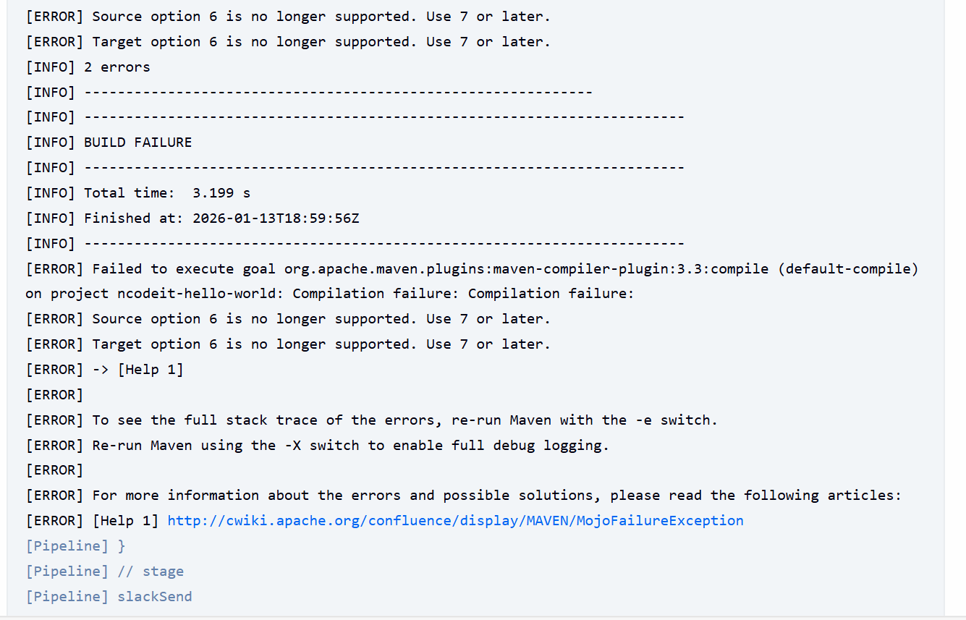

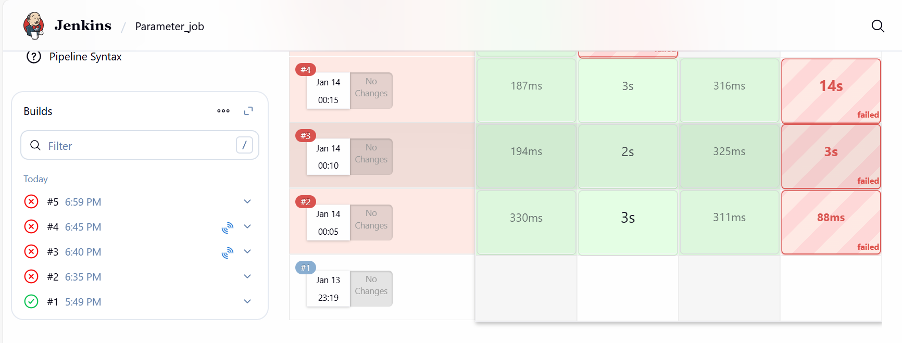

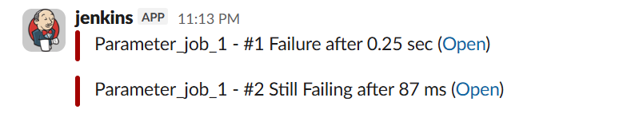
Conclusion
Parameterized jobs transform static scripts into dynamic, user-driven workflows. This approach reduces job duplication and allows the team to handle different deployment scenarios without changing the Jenkinsfile. It is a critical step toward achieving scalable Infrastructure as Code.

